2016

Stijn Dhondt

4/29/2016

Hangman door NeoMC

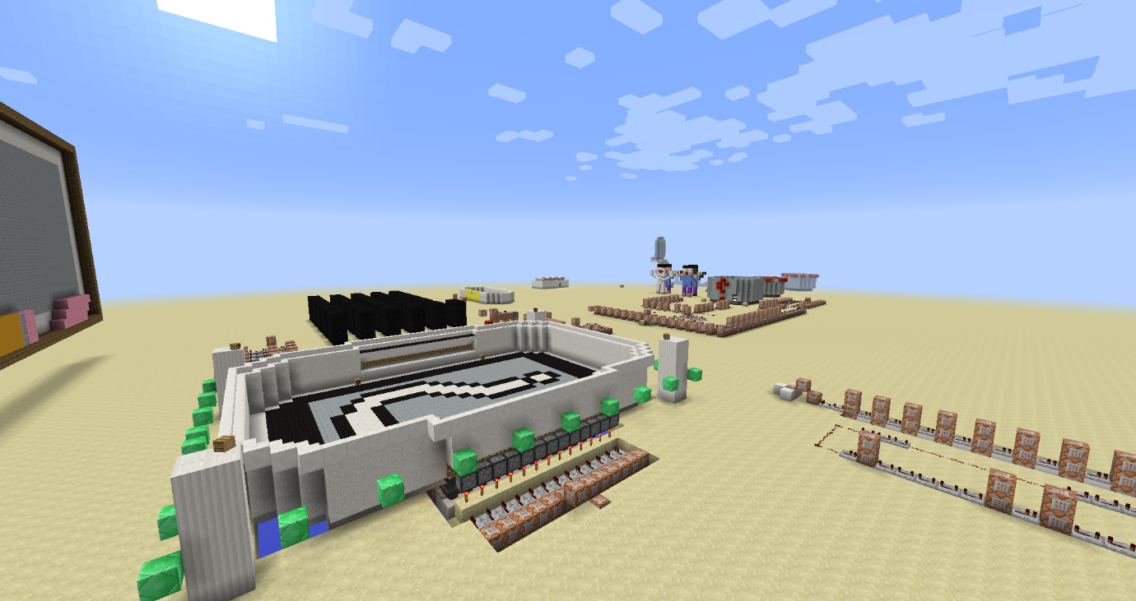

# Index

Contents

Index 1

Inleiding 2

Conventies 3

Onze eerste stappen 4

De ontvangstruimte. 4

Het pad van de woordenmaker 7

Wachtruimte voor de woordmaker 7

De ruimte waar het woord wordt gemaakt. 11

De Speelruimte 13

Het pad van de gisser. 14

De Speelruimte 17

Initialisatie van het spel 18

Initialisatie circuit 18

Eerste deel van het circuit 19

Tweede deel van het circuit 22

Derde deel van het circuit 25

De tikkende toren 27

Appendix A: Tell Raw/Tittle/Subtittle/Sign/Book het json formaat 30

Kleur 37

Vette tekst 37

Schuine tekst 37

Onderstrepen van tekst 37

Doorstrepen van tekst 37

Obfuscatie 37

Appendix B Block ID’s 39

# Inleiding

Welkom bij galgje (Hangman). Deze map is gemaakt door NeoMC. We zullen deze map gebruiken om stap voor stap het spel galgje te maken.

Men kan deze opdracht alleen of met 2 doen.

Naast de map Hangman is er ook een leerwereld. Hierin zijn bepaalde zaken uit de wereld.

Alle commando’s en blokken die moeten geplaatst worden zullen in dit document staan.

De commandos zullen via een pseudo taal vermeld staan.

Voor de coaches is er een afzonderlijke document met alle antwoorden in.

## Conventies

Hieronder vind u een aantal conventies terug.

Tekst op deze manier weergegeven toont de verschillende mogelijkheden van een commando in minecraft

<x> <y> <z> : coördinaten binnen de minecraft wereld

[<rot-x> <rot-y>]: optionele commando’s worden

[Tekst]: woorden in het commando die vervangen moeten worden.

Waardoor mende tekst moeten vervangen zal bij elke eerste gebruik van een commando uitgelegd staan.

***Doel***. Een doel, team naam,… wordt op deze manier weergegeven. Belangrijk is dat men het woord op dezelfde manier ingeeft als heet in het document staat. Dit wil zeggen inclusief de hoofdletters. Doel is niet hetzelfde als doel in minecraft.

De opdrachten worden in de vorm van pseudo taal weergegeven om de speler te helpen worden de woorden waar aan men aandacht moet geven schuin weergegeven.

VB:

* **Verplaats** de **dichtstbijzijnde speler** naar de volgende **coördinaten**

|  |  |
| --- | --- |
| X | 1052 |
| Y | 6 |
| Z | -91 |

Hieruit kunnen we afleiden dat we een teleporteer commando moeten uitvoeren op de dichtstbijzijnde speler.

* /TP @P 1052 6 -91

Commando’s die men rechtstreeks kan invoeren in de commando blok worden als volgt weergegeven.

/tellraw @a {"text":"","extra":[{"text":"[Hangman] ","color":"gold","bold":"true"},{"selector":"@p","color":"red"},{"text":" is ready to begin!","color":"dark_green"}]}

# Onze eerste stappen

## De ontvangstruimte.

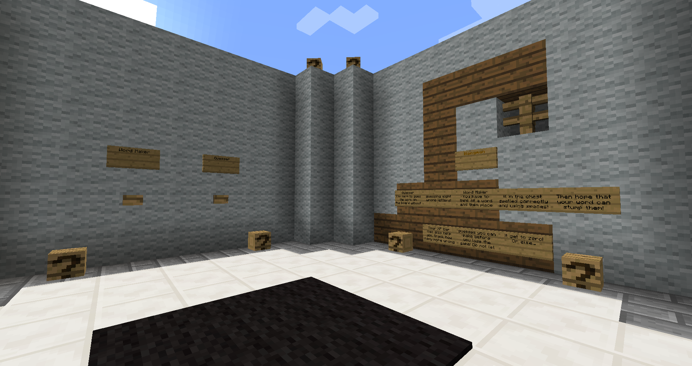

Wanneer we ons aanmelden op de map worden we gedropt in de ontvangstruimte. Hier kiezen de spelers welke functie ze willen uitvoeren in een partijtje galgje.

Aan de muur voor ons zien we 2 knoppen hangen. Elke knop moet de dichtstbijzijnde speler naar een andere locatie van de map zenden

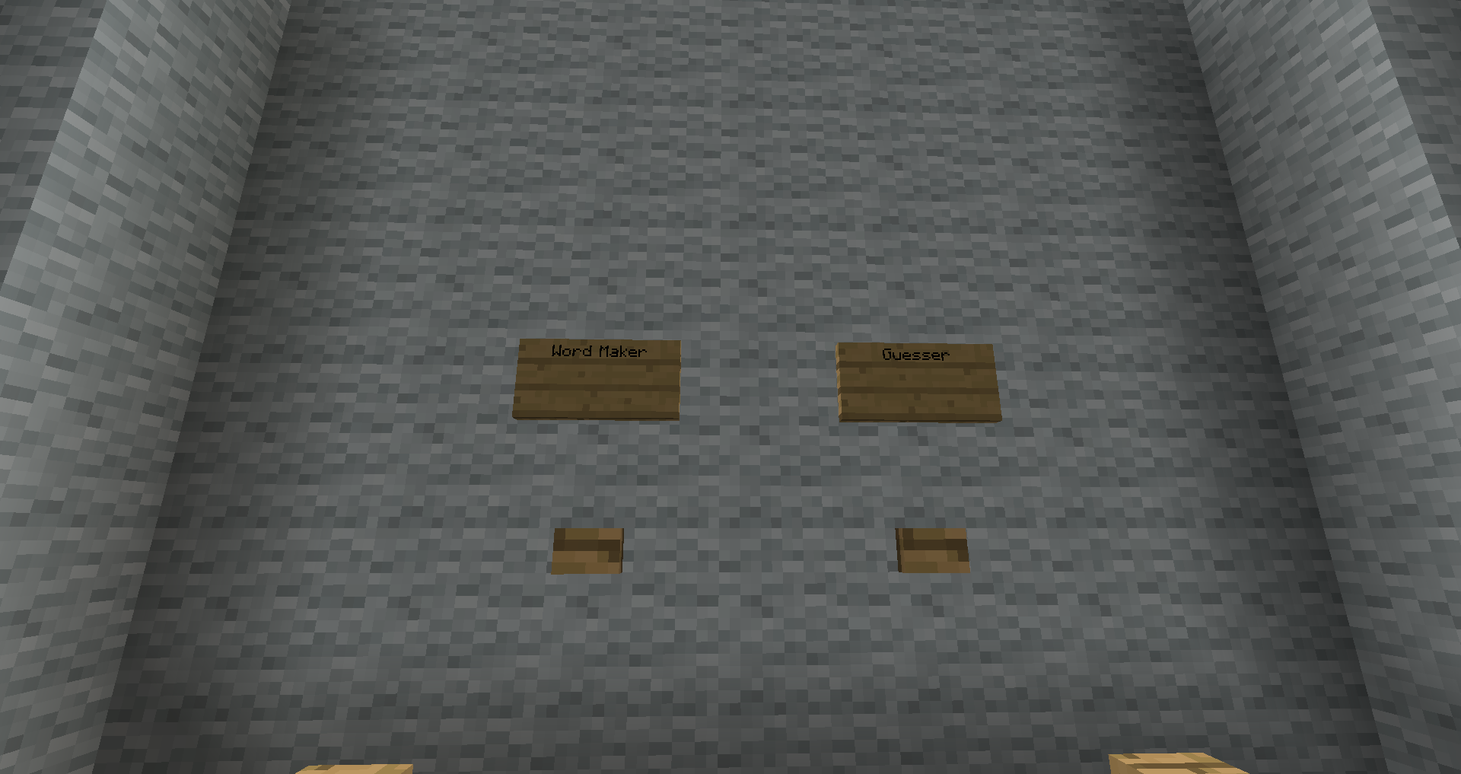

Opdracht 1.

Voorzie de knoppen van een commando block met teleportatie mogelijkheid.

Voor uw gemak zijn er een paar doorgangen gemaakt

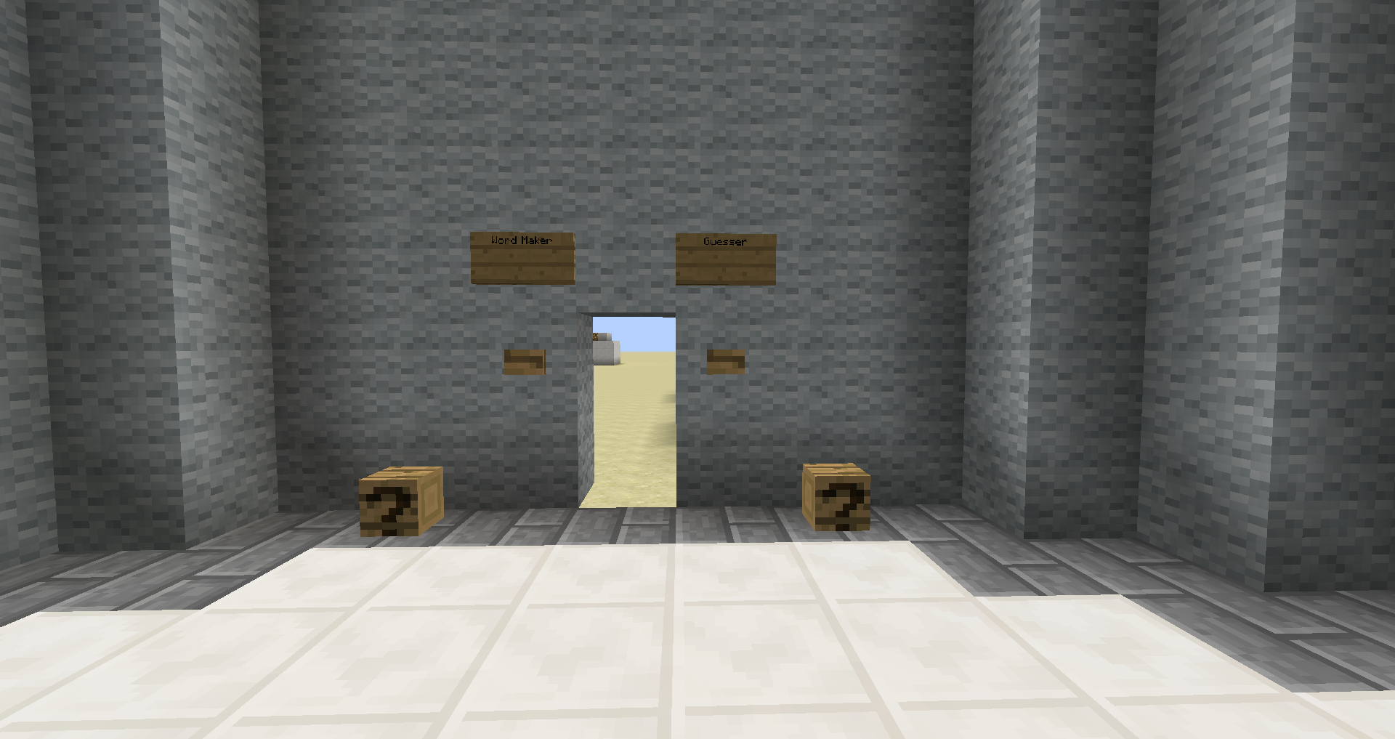

Plaats achter elke knop een commando blok.

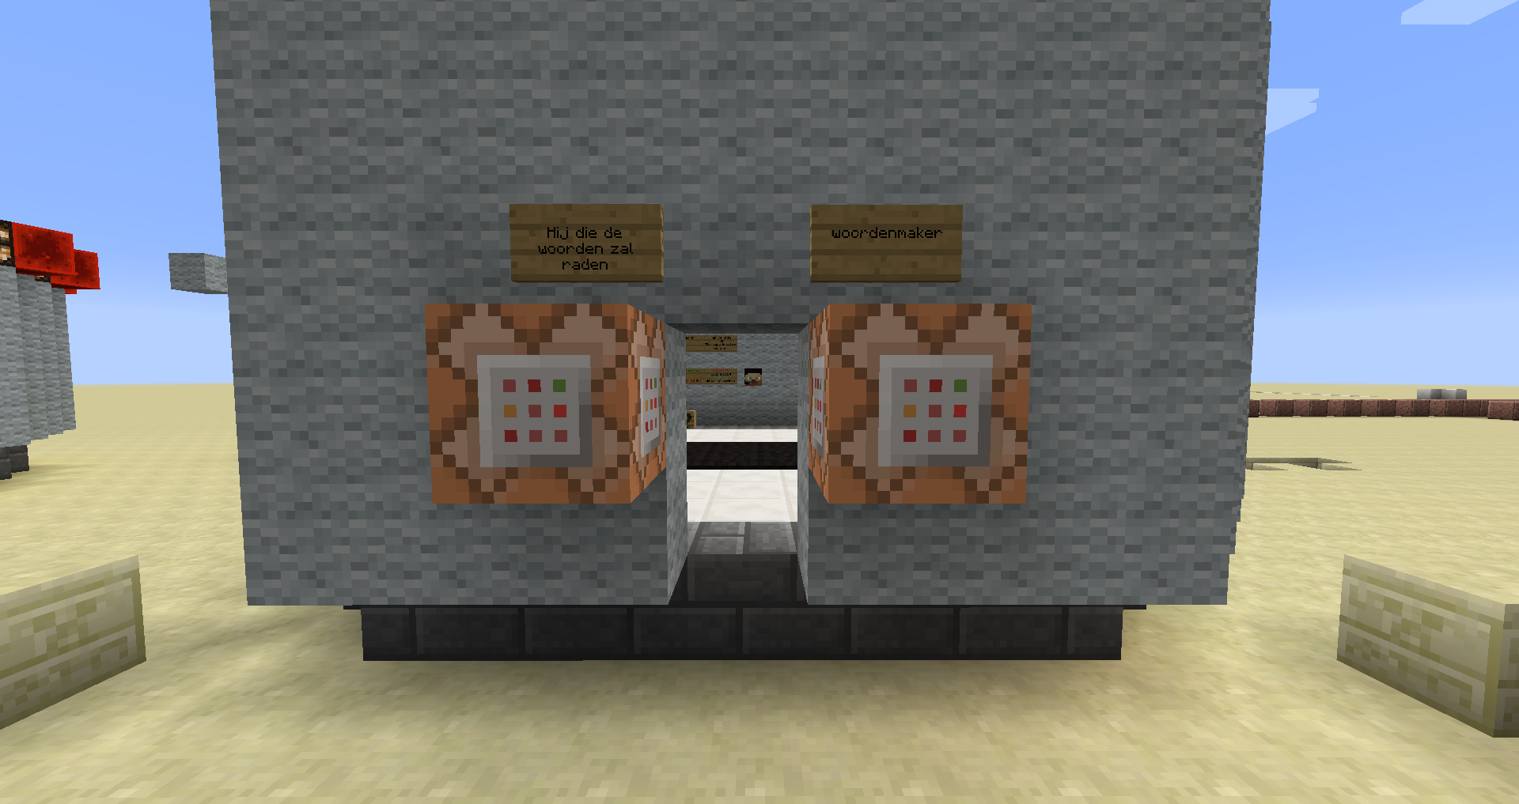

En voeg aan elke commando blok het teleportatie commando toe.

Opmaak teleportatie commando:

/tp [speler 1] [speler 2]

/tp [speler 1] <x> <y> <z> [<rot-x> <rot-y>]

/tp [selector] [speler 2]

/tp [selector] <x> <y> <z>[<rot-x> <rot-y>]

Speler1: De speller die geteleporteerd zal worden. Men kan hier een selector gebruiken.

Speler2: de speler waarnaar speler 1 geteleporteerd wordt.

<x> <y> <z>: de coördinaten naar waar speler1 geteleporteerd zal worden

[<rot-x> <rot-y>]: optionele parameter waarmee men speler1 kan draaien

Selector: een shorthand voorzien door minecraft.

@p Dichtstbijzijnde speler

@r Willekeurige speler

@a Alle spelers

@e Alle entiteiten

Commando voor woordenmaker

* **Teleporteer** de **dichtstbijzijnde speler** naar de volgende **coördinaten**

|  |  |
| --- | --- |
| X | 1052 |
| Y | 6 |
| z | -91 |

Commando voor “hij die de worden zal raden”

* **Teleporteer** de **dichtstbijzijnde speler** naar de volgende **coördinaten**

|  |  |
| --- | --- |
| X | 1052 |
| Y | 6 |
| z | -62 |

Om verder te gaan moeten we twee paden bewandelen.:

* Het pad van de woordenmaker.
* Het pad van hij die de woorden zal raden.

# Het pad van de woordenmaker

## Wachtruimte voor de woordmaker

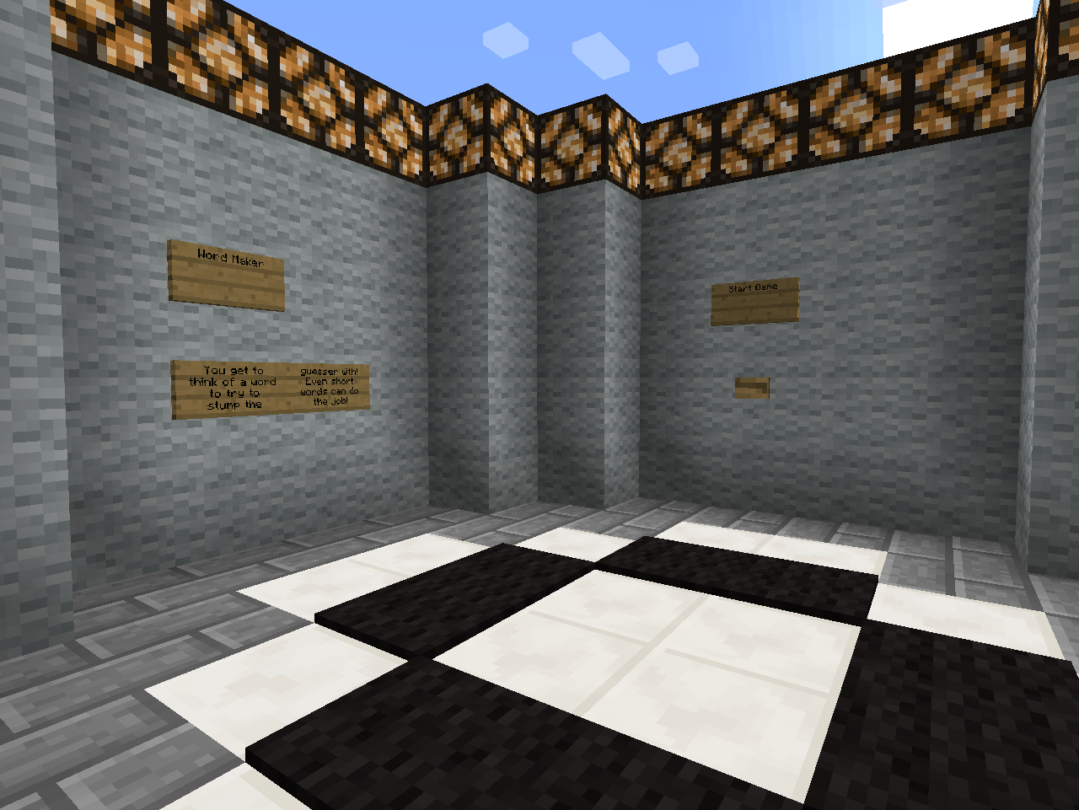

De woorden maker moet nu een woord bedenken van maximum 15 letters.

Eenmaal hij dit bedacht heeft kan hij op de knop start game klikken. Hierbij is het wachten tot de 2de speler “hij die de woorden zal raden” ook klaar is om te starten.

Opdracht 2

Maak de volgende opstelling.

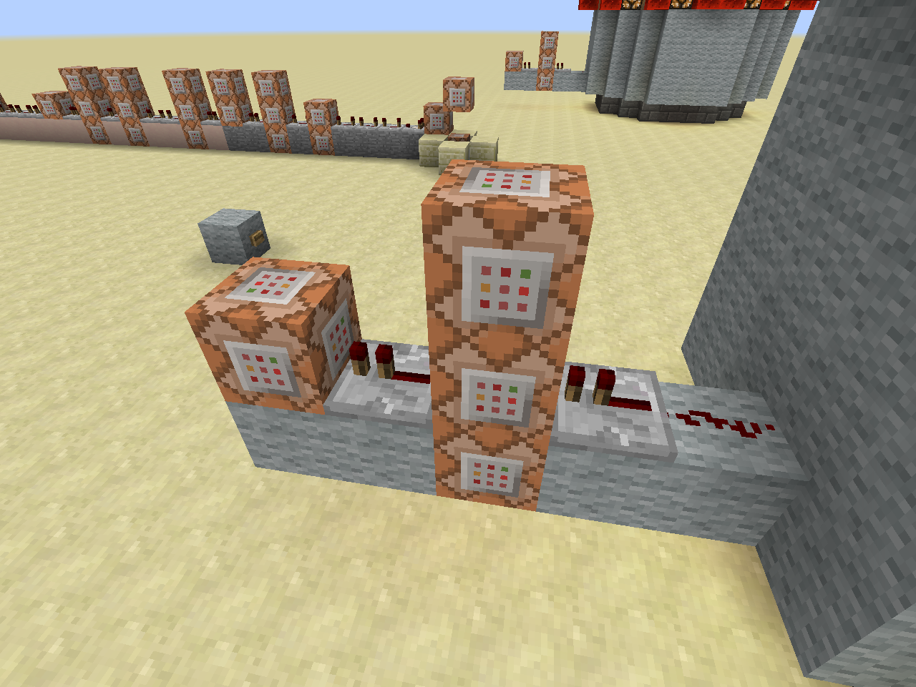

4

2

3

1

De drukknop op de muur zal via 1 redstone signaal naar een repeater gaan. Hierdoor voeren we eerst het commando van de middelste blok uit.

Eenmaal dit commando is uitgevoerd zullen de blokken onder en boven en de volgende blok hun commando’s uitvoeren. We gebruiken een overgang ’s repeater om het commando van de laatste blok niet meerdere keren uit te voeren.

Legende

|  |  |  |  |  |
| --- | --- | --- | --- | --- |
|  |  | C3 |  |  |
| C4 | R2 | C1 | R1 | RS1 |
| wol | wol | C2 | wol | Wol |

RS1: Redstone

R1 ,R2: repeaters:

1 Tick wachttijd

C1, C2, C3, C4: commando bokken

**C1:**

* Vertel het **scoreboard** dat **alle spelers** klaar zijn door het doel **Ready** met **één** te verhogen

/scoreboard players add <speler> <doel> <teller>

Speler: de naam van een speller of een van de selectors;

Doel: de naam van het doel

Teller: Met hoeveel moet de teller voor het doel optellen

**C2:**

* Vertel in het **chat venster** het bericht dat **de dichtstbijzijnde speler** klaar is om te beginnen

/tellraw <Speler> <raw json bericht>

Speler: de speller waarvoor het bericht is of een selector

raw json bericht: een manier waarop men een bericht kan opstellen, en kleuren zie volgende link voor alle mogelijk opties: <http://minecraft.gamepedia.com/Commands#Raw_JSON_text>. Zie de appendix voor een meer in detail uitleg.

Geef het volgende commando volledig in.

/tellraw @a {"text":"","extra":[{"text":"[Hangman] ","color":"gold","bold":"true"},{"selector":"@p","color":"red"},{"text":" is ready to begin!","color":"dark_green"}]}

Indien correct zien we volgende tekst

**[Hangman]** <speler> is ready to begin

**C3:**

* Vertel het **scoreboard** om de **dichtstbijzijnde speler** toe aan het **team *Maker***.

/scoreboard teams join <team> [speler(s)...]

Team: Naam van het team

Speler(s): de speler of spelers die men wil toevoegen. Om alle speler te selecteren kan “*” gebruiken.

**C4:**

* **Verwijder** de **drukknop** door deze te **vervangen** met een **luchtblok**.

Locatie van de drukknop

|  |  |
| --- | --- |
| X | 1055 |
| Y | 5 |
| z | -92 |

/setblock <x> <y> <z> <blok> [data] [oudeBlokAfhandeling]

<x> <y> <z>: de locatie waar men een block wil plaatsen.

Blok: de minecraft blok id naam. Informatie over de blok id’s vindt men in de appendix.

Data: waarde tussen 0 en 15. Indien niet nodig is deze 0.

oudeBlokAfhandeling: Wat te doen met de oude block. Vaste waarden binnen minecraft

Destroy: oude block wordt verwijderd net alsof het door een speler is verwijderd. Men hoort ook het blok breek geluid

Keep: enkel lucht blokken worden vervangen

Replace: de blok verdwijnt zonder een spoor na te laten.

Wol: wol blokken

## De ruimte waar het woord wordt gemaakt.

Deze ruimte vind je terug op coördinaten 1100, 3, -163.

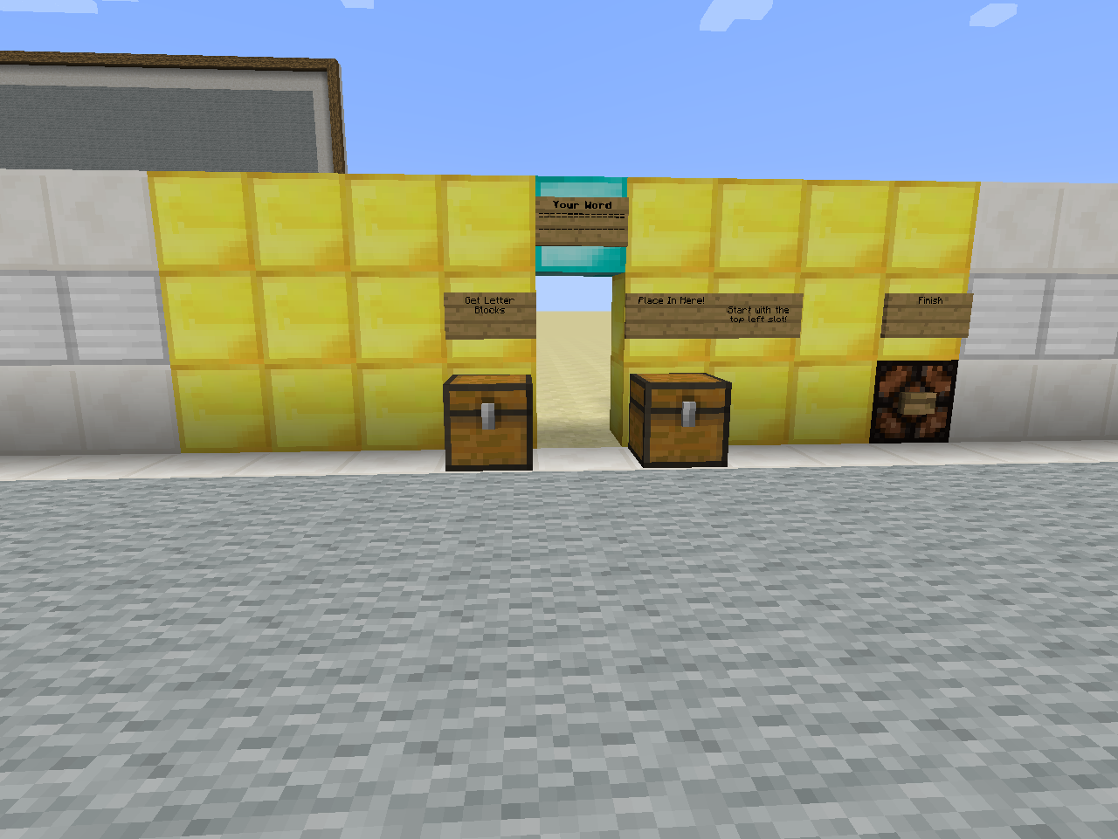

In deze ruimte kan men het woord samenstellen.

Men kiest de letter uit de linker koffer en plaatst ze in de juiste volgorde in de rechter koffer.

Opdracht 3

Maak de volgende opstelling.

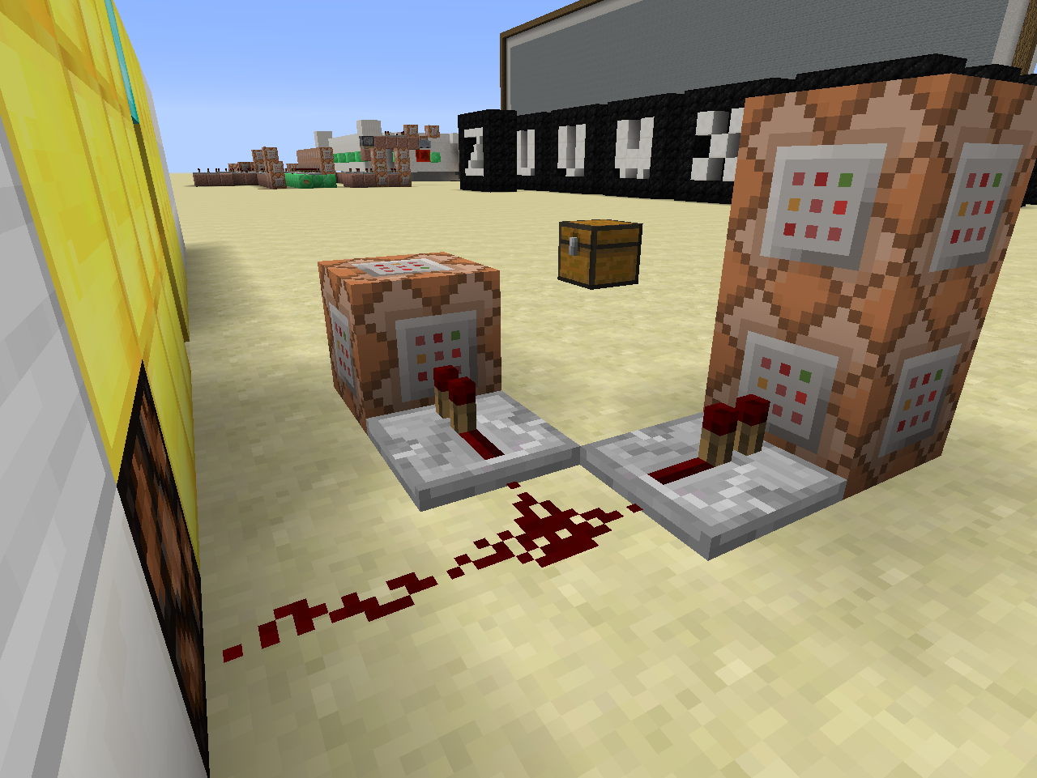

3

2

1

**C1:**

* Geef de **dichtstbijzijnde speler 8 levels** aan **xp**

/xp <getal> [speler]

/xp <getal>L [speler]

Getal: geeft het aantal xp punten aan die men aan een speler wil geven

Getal L: geeft het aantal xp level men aan een speler wil geven.

Speler: de speler aan wie men de xp wil geven. Kan ook een selector zijn

C2:

* **Teleporteer** **alle spelers** die in het **team Maker** zitten

|  |  |
| --- | --- |
| X | 1032 |
| Y | 6 |
| z | -203 |

Een groep teleportatie commando:

/tp <selector>[team=teamNaam] <x> <y> <z>

Selector: een shorthand voorzien door minecraft.

@p Dichtstbijzijnde speler

@r Willekeurige speler

@a Alle spelers

@e Alle entiteiten

teamNaam: de naam van het team waartoe de speler moet behoren.

C3

* Zet op het **scorebord** het doel **SlotAdvance** voor de **dichtstbijzijnde speler** op **17**

/scoreboard players set <speler> <doel> <score>

Speler: de naam van een speller of een van de selectors;

Doel: de naam van het doel

Score: wat de score is voor dat doel.

## De Speelruimte

Onze woordmaker wordt nu in de speel ruimte gedropt. En het raden kan beginnen.

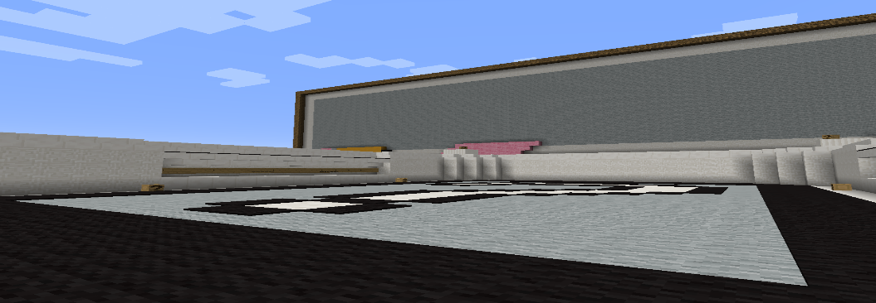

# Het pad van de gisser.

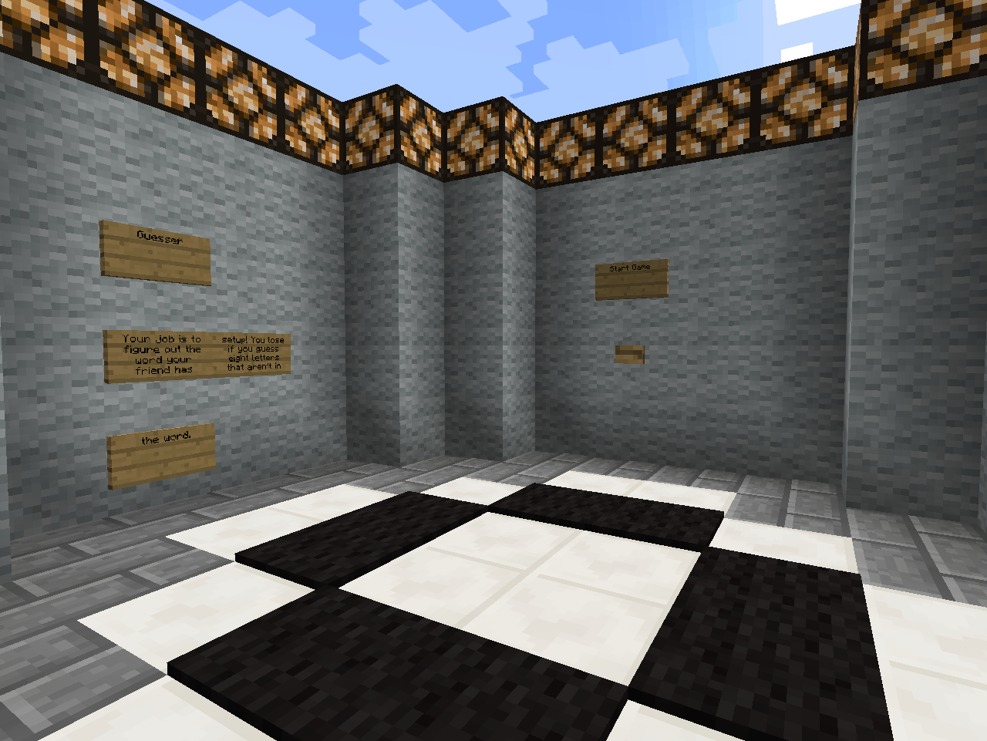

De rader moet nu wachten tot de woordmaker klaar is.

Hij kan rechtstreeks op de knop start game drukken en wachten op de andere speler.

Opdracht 4

Maak de volgende opstelling.

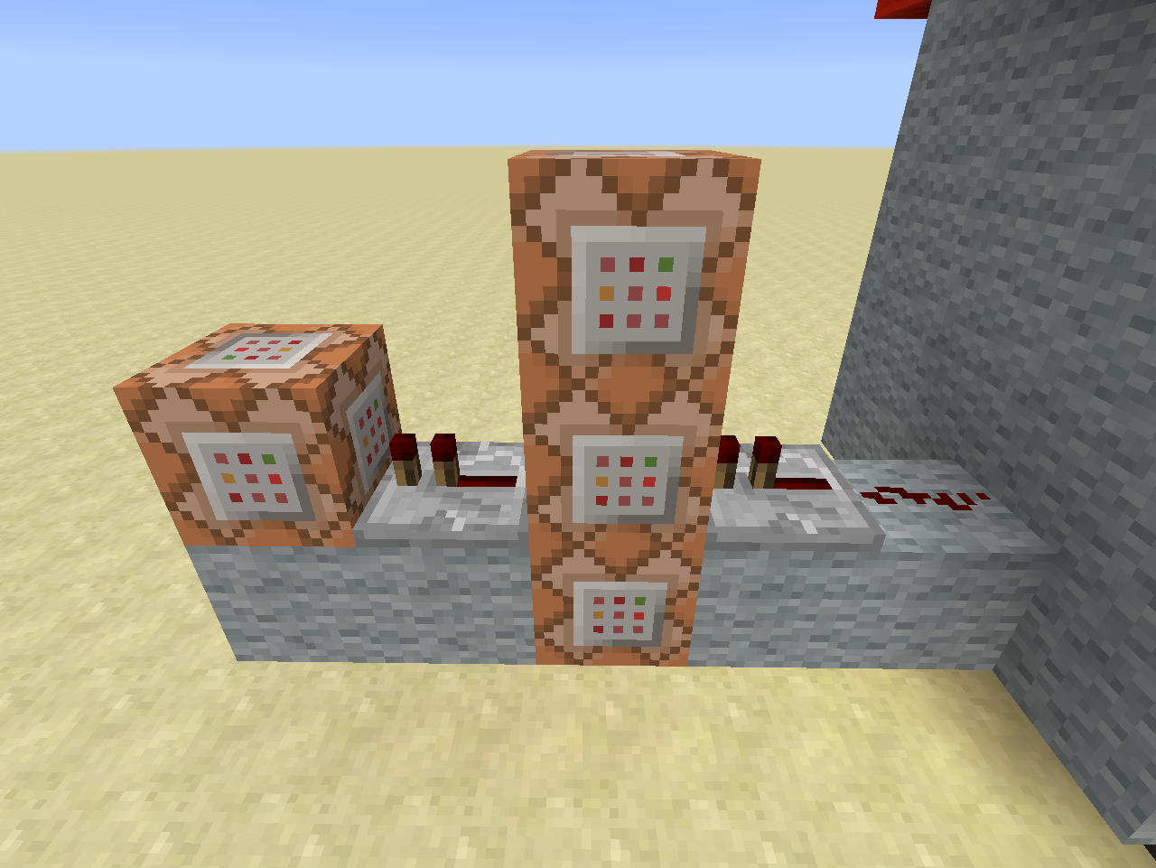

4

2

3

1

De drukknop op de muur zal via 1 redstone signaal naar een repeater gaan. En eerst het commando van de middelste blok uitvoeren.

Eenmaal dit commando is uitgevoerd zulle de blokken onder en boven en de volgende blok hun commando’s uitvoeren. We gebruiken een overgang ’s repeater om het commando van de laatste blok niet meerdere keren uit te voeren.

Legende

|  |  |  |  |  |
| --- | --- | --- | --- | --- |
|  |  | C3 |  |  |
| C4 | R2 | C1 | R1 | Rd1 |
| wol | wol | C2 | wol | Wol |

Rd1: redstone dust

R1 ,R2: repeaters:

1 Tick wachttijd

C1, C2, C3, C4: commando bokken

**C1:**

* Vertel het **scoreboard** dat **alle spelers** klaar zijn door het **doel** **Ready** met **één** te verhogen

/scoreboard players add <speler> <doel> <teller>

Speler: de naam van een speller of een van de selectors;

Doel: de naam van het doel

Teller: Met hoeveel moet de teller voor het doel optellen

**C2:**

* Vertel in het **chat venster** het bericht dat de **woordenrader** klaar is om te beginnen

/tellraw <Speler> <raw json bericht>

Speler: de speller waarvoor het bericht is of een selector

raw json bericht: een manier waarop men een bericht kan opstellen, en kleuren zie volgende link voor alle mogelijk opties: <http://minecraft.gamepedia.com/Commands#Raw_JSON_text>

/tellraw @a {"text":"","extra":[{"text":"[Hangman] ","color":"gold","bold":"true"},{"selector":"@p","color":"yellow"},{"text":" is ready to begin!","color":"dark_green"}]}

**[Hangman]** <speler> is ready to begin

**C3:**

* Vertel het **scorebord** om de dichtsbijzijnde speler toe te voegen aan het team **Guess**

/scoreboard teams join <team> [speler(s)...]

Team: Naam van het team

Speler(s): de speler of spelers die men wil toevoegen. Om alle speler te selecteren kan “*” gebruiken.

**C4:**

* **Verwijder** de **drukknop** door deze te **vervangen** met een **luchtblok**.

Locatie van de drukknop

|  |  |
| --- | --- |
| X | 1055 |
| Y | 5 |
| z | -63 |

/setblock <x> <y> <z> <blok> [data] [oudeBlokAfhandeling]

<x> <y> <z>: de locatie waar men een block wil plaatsen.

Blok: de minecraft blok id naam. Informatie over de blok id’s vindt men [hier](http://minecraft.gamepedia.com/Data_values#Block_IDs).

Optionele waarde tussen 0 en 15

oudeBlokAfhandeling: Wat te doen met de oude block. Vaste waarden binnen minecraft

Destroy: oude block wordt verwijderd net alsof het door een speler is verwijderd. Men hoort ook het blok breek geluid

Keep: enkel lucht blokken worden vervangen

Replace: de blok verdwijnt zonder een spoor na te laten.

Wol: wol blokken

## De Speelruimte

Als beide spelers klaar zijn wordt de rader in de speel ruimte gedropt.

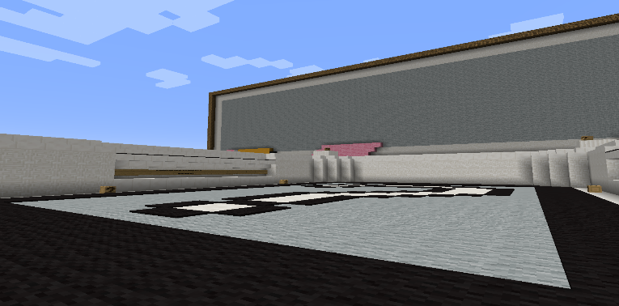

# Initialisatie van het spel

Nu beide spelers melden dat ze klaar zijn is het tijd om een nieuw spel te initialiseren. We teleporteren de gebruikers naar de volgende ruimtes en set/resetten wat blokken en doelen.

## Initialisatie circuit

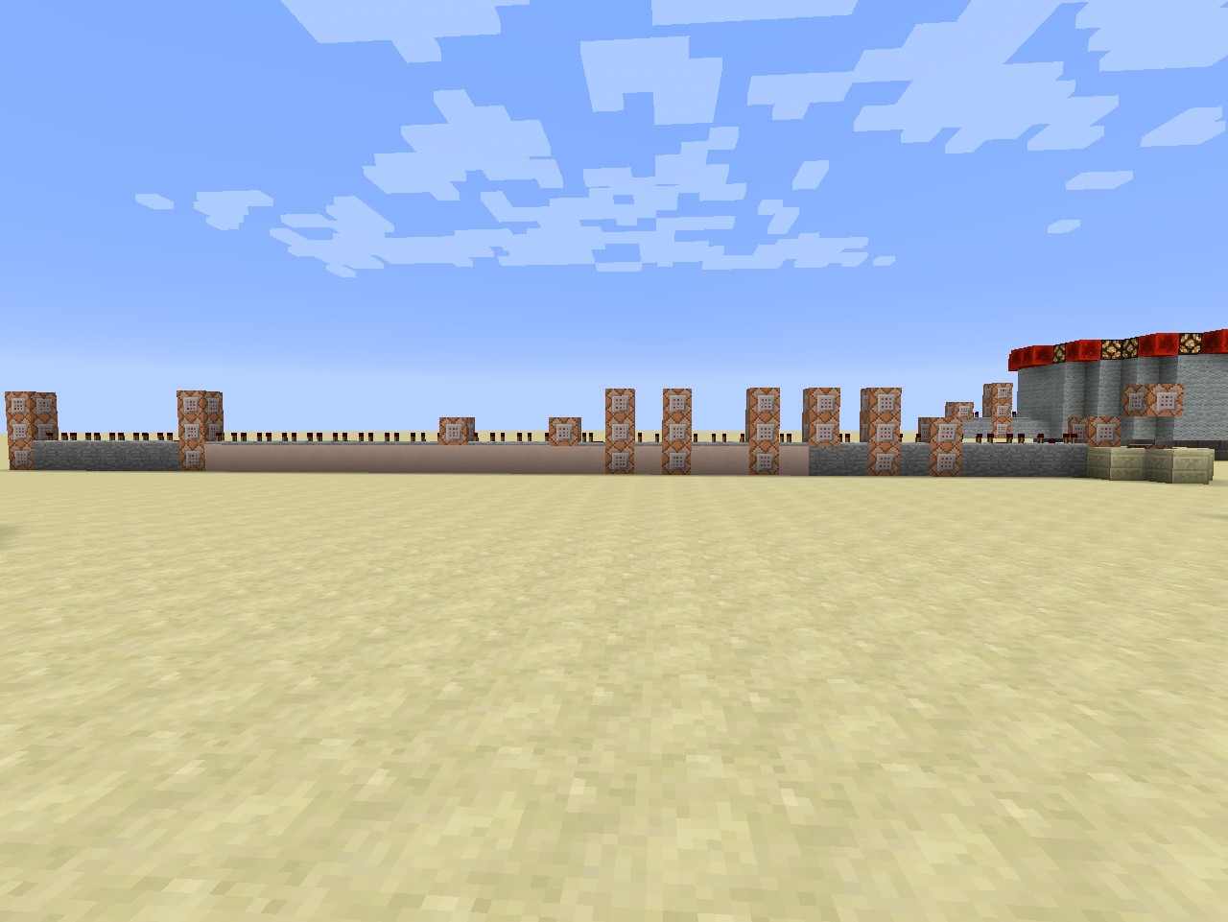

Opdracht 7

Opdracht 6

Opdracht 5

Het initialisatie circuit is een lange rij commando’s en repeaters.

We zullen dit dan ook in drie stukken kappen.

Opdracht 5: van rechts naar links loop vanaf de zandsteen tot aan de witteklei

Opdracht 6: zijn alle commando blokken op de witte klei

Opdracht 7: de commando blokken op de stenen.

### Eerste deel van het circuit

Opdracht 5

Vanaf hier krijgt men enkel nog de nodige informatie. De commando’s die al gebruikt zijn staan er niet meer als voorbeeld bij. Nieuwe commando’s worden eenmalig getoond met informatie.

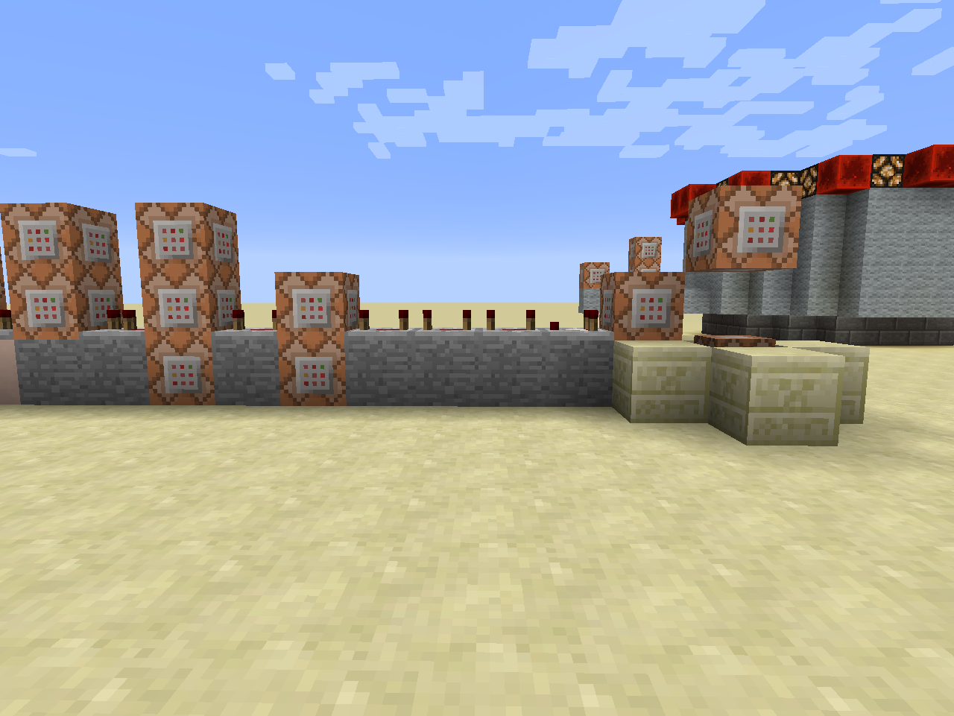

CC1

8

9

7

6

5

4

3

2

1

|  |  |  |  |  |  |  |  |  |  |  |
| --- | --- | --- | --- | --- | --- | --- | --- | --- | --- | --- |
| C9 |  | C7 |  | | | | | | | C1 |
| C8 | R6 | C5 | R4 | C3 | R3 | R2 | R1 | cmp1 | C2 |  |
| steen | steen | C6 | steen | C4 | Steen | Steen | Steen | Steen | steen | CC1 |
|  | | | | | | | | | | Rb1+ar |

Rb1 => dit is een blok redstone en is aanwezig

Ar => activator rail. Een mijnkar met commandoblok zal elke 4 game ticks activeren

**C1:**

* **Vul** een gebied van **1*1*3** met **lucht relatief ten opzichte van de commandoblok.**

/fill <x1> <y1> <z1> <x2> <y2> <z2> <blok>

<x1> <y1> <z1>, <x2> <y2> <z2> coördinaten van 2 tegenovergesteld hoeken

blok: de minecraft blok id/naam. Informatie over de blok id’s vindt men [hier](http://minecraft.gamepedia.com/Data_values#Block_IDs).

**CC1:**

* **Vul** een gebied van **1*1*3** met **redstone-blokken relatief ten opzichte van de commandoblok.**

/fill <x1> <y1> <z1> <x2> <y2> <z2> <blok>

<x1> <y1> <z1>, <x2> <y2> <z2> coördinaten van 2 tegenovergesteld hoeken

blok: de minecraft blok id naam. Informatie over de blok id’s vindt men [hier](http://minecraft.gamepedia.com/Data_values#Block_IDs).

**C2:**

* **Test** of **alle spelers** op de startknop hebben geklikt =>doel **Ready**.

/testfor <speler> [tag]

Tag iets van het type NBT Tag. In het geval van een doel heeft men de volgende 2 mogelijkheden.

Score_**doel** =2 =>de voorwaarde is ok indien het Doel 0,1 of 2 is. Of anders gezegd kleiner dan of gelijk aan 2

Score_**doel**_min=2 => het doel is minstens 2 of hoger

/testfor @a[score_Ready_min=2]

**C3:**

* Zet het doel “**End**” op **1** voor **alle spelers**

Hint : scoreboard players set

**C4:**

* Zet het doel “**Guess**” op **0** voor **alle spelers**.

**C5:**

* Vertel in het **chat venster** dat **alle spelers** klaar is en dat het spel zal beginnen eens de woordenmaker zijn woord heeft gemaakt.

/tellraw @a {"text":"","extra":[{"text":"[Hangman] ","color":"gold","bold":"true"},{"text":"Everybody is ready! The game will begin once the word maker finishes setting up the word!","color":"dark_green"}]}

**C6:**

* **Teleporteer** **alle spelers** van het **team Maker**

|  |  |
| --- | --- |
| X | 1101 |
| Y | 4 |
| z | -165 |

**C7:**

* **Teleporteer alle spelers** van het **team** **Guess**.

|  |  |
| --- | --- |
| X | 1032 |
| Y | 6 |
| z | -203 |

C8:

* Geen commando

**C9:**

* **Zet** voor **alle spelers** het **Ready** doel op **0**

### Tweede deel van het circuit

Opdracht 6

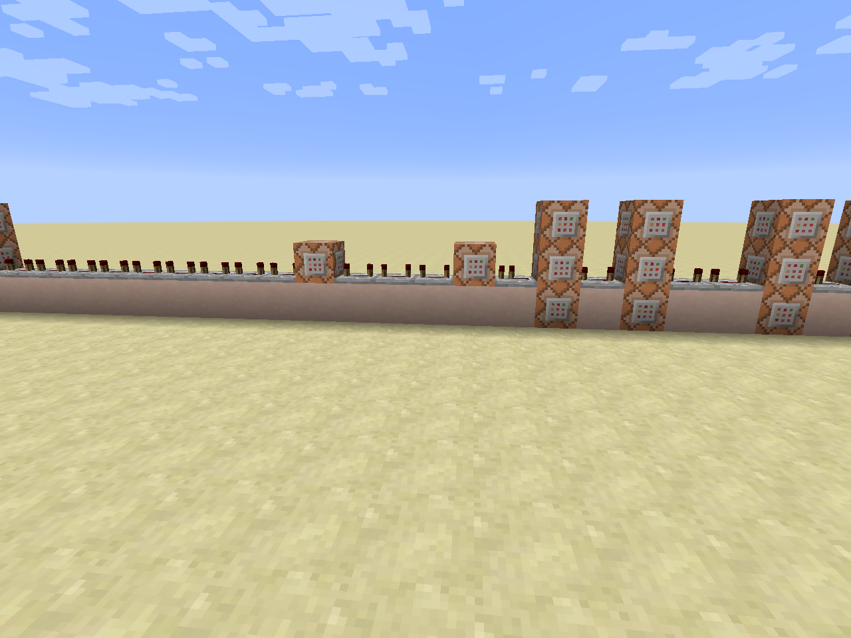

10

11

9

8

7

6

5

4

3

2

1

|  |  |  |  |  |  |  |  |  |  |  |  |  |  |  |  |  |  |  |  |
| --- | --- | --- | --- | --- | --- | --- | --- | --- | --- | --- | --- | --- | --- | --- | --- | --- | --- | --- | --- |
|  | | | | | | | | | | | | | C9 |  | C6 |  | | C3 |  |
| R15 | R14 | R13 | R12 | R11 | R10 | R9 | C11 | R8 | R7 | R6 | C10 | R5 | C7 | R4 | C4 | R3 | R2 | C1 | R1 |
|  | | | | | | | | | | | | | C8 |  | C5 |  | | C2 |  |

**C1:**

* Maak voor **alle spelers** hun **inventaris leeg**

/clear <speler>

Speler: naam van de speler of een selector

**C2:**

* **Verander** de **spelmodus** voor **alle spelers** van het **team Maker** naar **creatief**

/gamemode <mode> [speler]

Mode: de mogelijke speel modussen

1. Overleven
2. Creatief
3. Avontuur
4. Bijstander

Speler: de naam van de speller of een selector waarvoor men de spel modus wil veranderen

**C3:**

* **Verander** de **spelmodus** voor **alle spelers** van het **team Guess** naar **avontuur**

**C4:**

* Geen commando

**C5:**

* **Kloon** een gebied

|  |  |  |  |  |  |
| --- | --- | --- | --- | --- | --- |
| X1 | 1056 | X2 | 1056 | X | 1045 |
| Y1 | 3 | Y2 | 3 | Y | 4 |
| Z1 | -207 | Z2 | -195 | Z | -210 |

/clone <x1> <y1> <z1> <x2> <y2> <z2> <x> <y> <z>

<x1> <y1> <z1> <x2> <y2> <z2>: het gebied dat men wil klonen.

<x> <y> <z>: Startpositie waarde kloon moet komen.

**C6:**

* **Kloon** een gebied

|  |  |  |  |  |  |
| --- | --- | --- | --- | --- | --- |
| X1 | 1058 | X2 | 1058 | X | 1095 |
| Y1 | 3 | Y2 | 3 | Y | 4 |
| Z1 | -207 | Z2 | -195 | Z | -210 |

**C7:**

* Vertel in het **chat venster** voor **alle spelers** in het **team Maker** wat ze moeten doen.

/tellraw @a[team=Maker] {"text":"","extra":[{"text":"[Hangman] ","color":"gold","bold":"true"},{"text":"Take blocks from the chest on the left and order them to spell the word in the chest on the right! Enter it as if you were reading a book; start at the top-left and move to the right! You can enter up to 15 letters!","color":"dark_green"}]}

**C8:**

* **Kloon** een gebied

|  |  |  |  |  |  |
| --- | --- | --- | --- | --- | --- |
| X1 | 1066 | X2 | 1065 | X | 1055 |
| Y1 | 3 | Y2 | 3 | Y | 5 |
| Z1 | -86 | Z2 | -86 | Z | -92 |

**C9:**

* **Kloon** een gebied

|  |  |  |  |  |  |
| --- | --- | --- | --- | --- | --- |
| X1 | 1066 | X2 | 1065 | X | 1055 |
| Y1 | 3 | Y2 | 3 | Y | 5 |
| Z1 | -86 | Z2 | -86 | Z | -63 |

**C10:**

* **Zet** een **blok redstone** op de volgende positie

|  |  |
| --- | --- |
| X | 1096 |
| Y | 21 |
| z | -90 |

Hint setblock

**C11:**

* **Zet** een **blok lucht** op de volgende positie.

|  |  |
| --- | --- |
| X | 1096 |
| Y | 21 |
| z | -90 |

Hint setblock

### Derde deel van het circuit

Opdracht 7

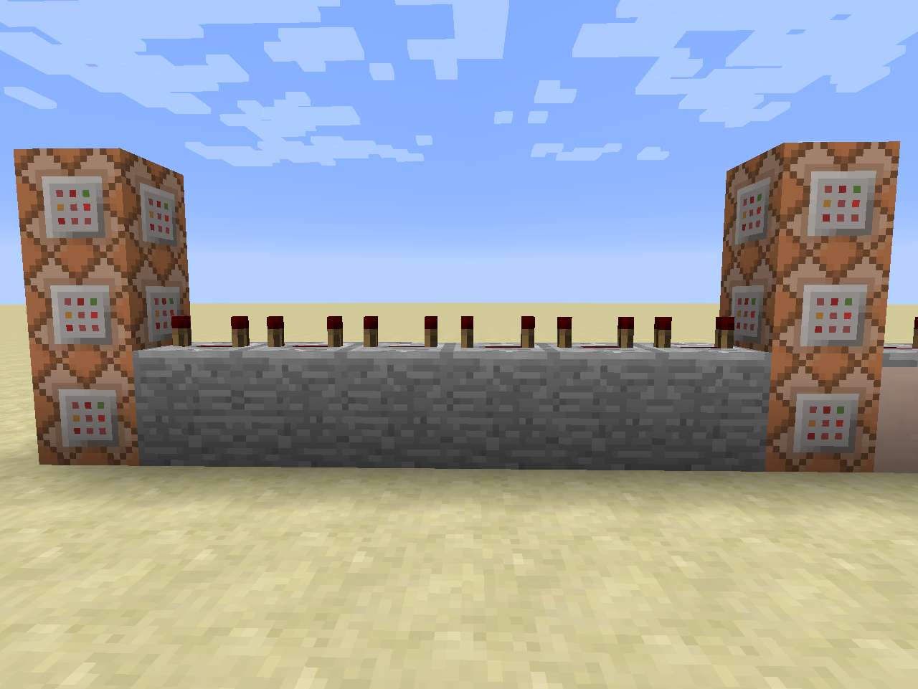

5

4

6

3

2

1

|  |  |  |  |  |  |  |
| --- | --- | --- | --- | --- | --- | --- |
| C6 |  | | | | | C2 |
| C4 | R5 | R4 | R3 | R2 | R1 | C1 |
| C5 |  |  |  |  |  | C3 |

**C1:**

* **Zet** een **hopper** op de volgende positie

|  |  |
| --- | --- |
| X | 1094 |
| Y | 13 |
| z | -89 |

Hint setblock

**C2:**

* **Zet** een **hopper** op de volgende positie

|  |  |
| --- | --- |
| X | 1094 |
| Y | 13 |
| z | -91 |

Hint setblock

**C3**:

* **Vul** een gebied met **hoppers** op de volgende positie

|  |  |  |  |
| --- | --- | --- | --- |
| X1 | 1092 | X2 | 1092 |
| Y1 | 3 | Y2 | 3 |
| Z1 | -89 | Z2 | -91 |

Hint fill

C4:

* **Zet** een **blok lucht** op de volgende positie

|  |  |
| --- | --- |
| X | 1094 |
| Y | 13 |
| z | -89 |

Hint setblock

C5:

* **Zet** een **blok lucht** op de volgende positie

|  |  |
| --- | --- |
| X | 1094 |
| Y | 13 |
| z | -91 |

Hint setblock

C6:

* **Vul** een gebied met **lucht** op de volgende positie

|  |  |  |  |
| --- | --- | --- | --- |
| X1 | 1092 | X2 | 1092 |
| Y1 | 3 | Y2 | 3 |
| Z1 | -89 | Z2 | -91 |

Hint fill

# De tikkende toren

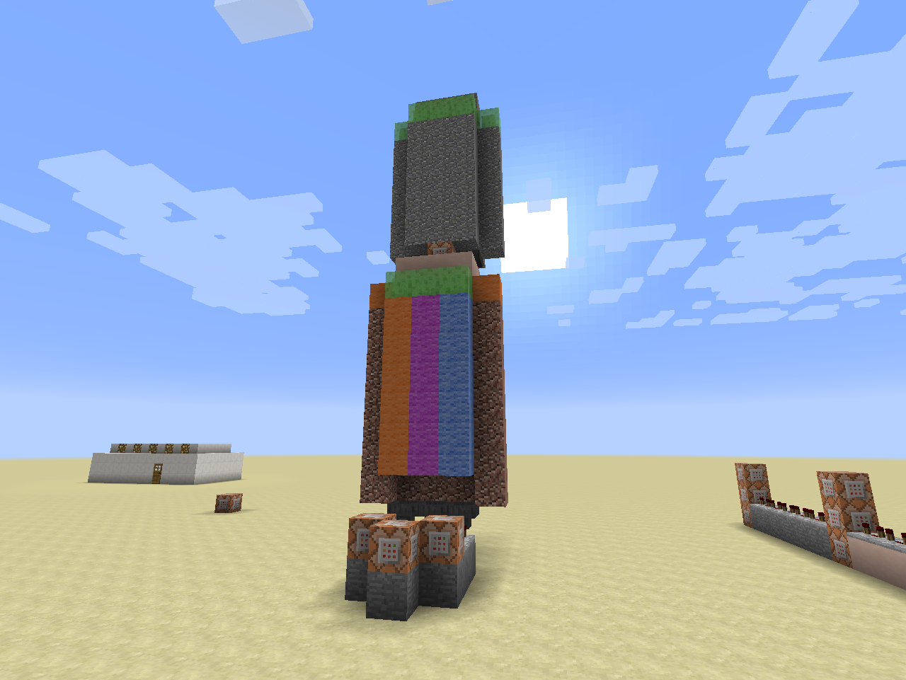 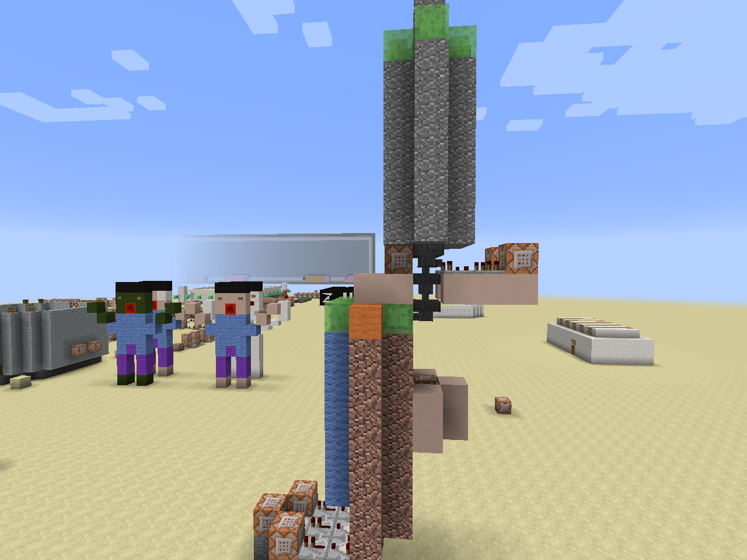

CC1

6

5

4

2

1

3

4

Opdracht 8

C1:

* **Kloon** een gebied

|  |  |  |  |  |  |
| --- | --- | --- | --- | --- | --- |
| X1 | 1071 | X2 | 1063 | X | 1050 |
| Y1 | 12 | Y2 | 3 | Y | 15 |
| Z1 | -109 | Z2 | -108 | Z | -240 |

C2:

* **Kloon** een gebied

|  |  |  |  |  |  |
| --- | --- | --- | --- | --- | --- |
| X1 | 1081 | X2 | 1073 | X | 1050 |
| Y1 | 12 | Y2 | 3 | Y | 15 |
| Z1 | -112 | Z2 | -111 | Z | -240 |

C3:

* **Kloon** een gebied

|  |  |  |  |  |  |
| --- | --- | --- | --- | --- | --- |
| X1 | 1071 | X2 | 1063 | X | 1050 |
| Y1 | 12 | Y2 | 3 | Y | 15 |
| Z1 | -112 | Z2 | -111 | Z | -240 |

C4:

* **Zet** een **blok lucht** op de volgende positie

|  |  |
| --- | --- |
| X | ~ |
| Y | ~-1 |
| z | ~ |

CC1:

* **Zet** een **redstone blok** op de volgende positie

|  |  |
| --- | --- |
| X | ~-1 |
| Y | ~4 |
| z | ~ |

C5:

* **Kloon** een gebied

|  |  |  |  |  |  |
| --- | --- | --- | --- | --- | --- |
| X1 | 1081 | X2 | 1073 | X | 1050 |
| Y1 | 12 | Y2 | 3 | Y | 15 |
| Z1 | -109 | Z2 | -108 | Z | -240 |

C6:

* **Kloon** een gebied

|  |  |  |  |  |  |
| --- | --- | --- | --- | --- | --- |
| X1 | 1081 | X2 | 1073 | X | 1050 |
| Y1 | 12 | Y2 | 3 | Y | 15 |
| Z1 | -109 | Z2 | -108 | Z | -240 |

# Het controlesysteem van de win voorwaarden.

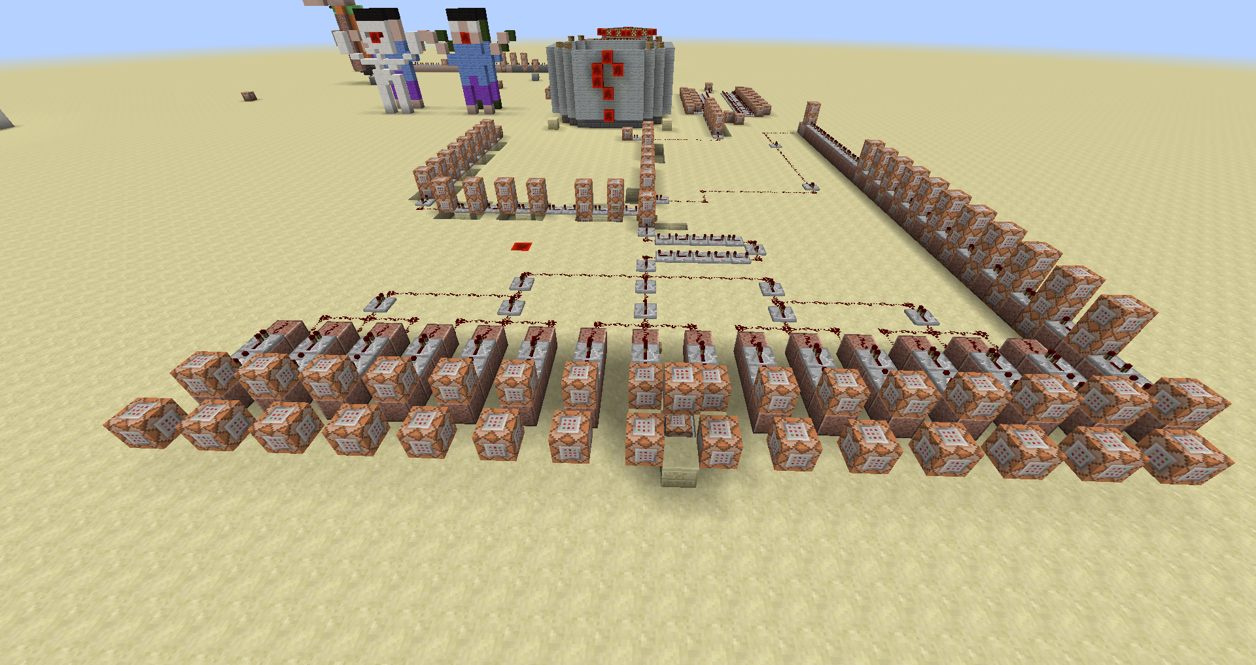

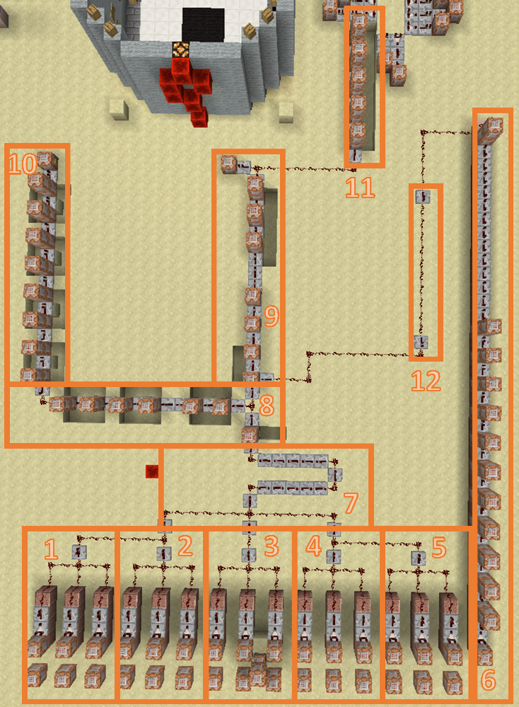We delen dit circuit op in 12 kleinere stukjes.

Groepen 1 tot en met 5 zijn herhalen van dezelfde code met veranderingen in de vergelijking. De achterste rij commandoblokken in deze 5 groepen bevat geen code.

Opdracht 9

## 1ste groep: commandoblokken 1-3

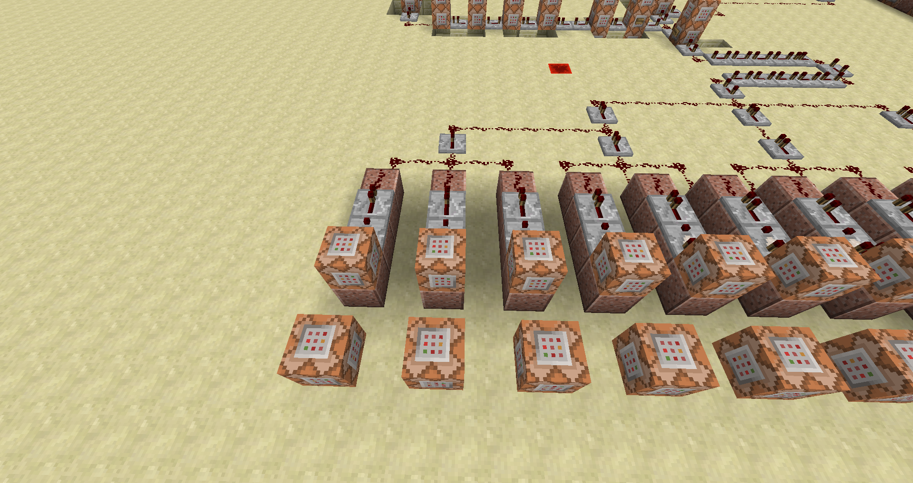 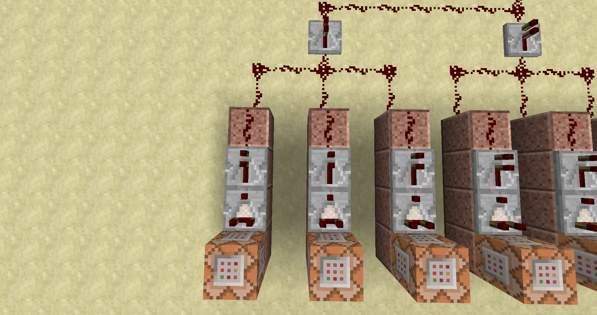

**1**

**2**

**3**

**3**

**2**

**1**

C1:

* **Test** de volgende **doelen**:

**score_Correct** gelijk aan 1

**score_Endcap** gelijk aan 1

**score_Mode** hoger dan of gelijk aan 1

**score_Fail** kleiner dan of gelijk aan 0

C2:

* **Test** de volgende **doelen**:

**score_Correct** gelijk aan 2

**score_Endcap** gelijk aan 2

**score_Mode** hoger dan of gelijk aan 1

**score_Fail** kleiner dan of gelijk aan 0

C3:

* **Test** de volgende **doelen**:

**score_Correct** gelijk aan 3

**score_Endcap** gelijk aan 3

**score_Mode** hoger dan of gelijk aan 1

**score_Fail** kleiner dan of gelijk aan 0

## 2de groep: commandoblokken 4-6

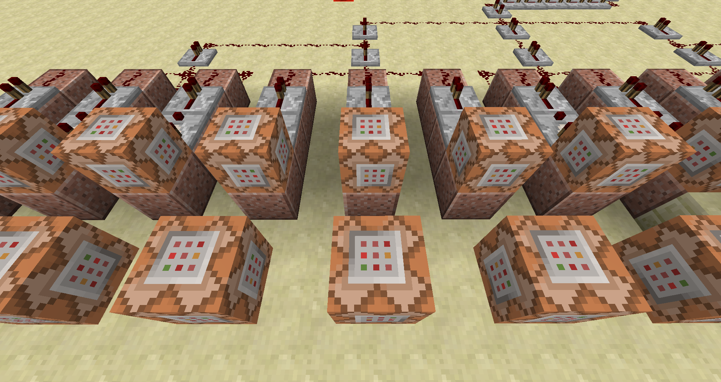 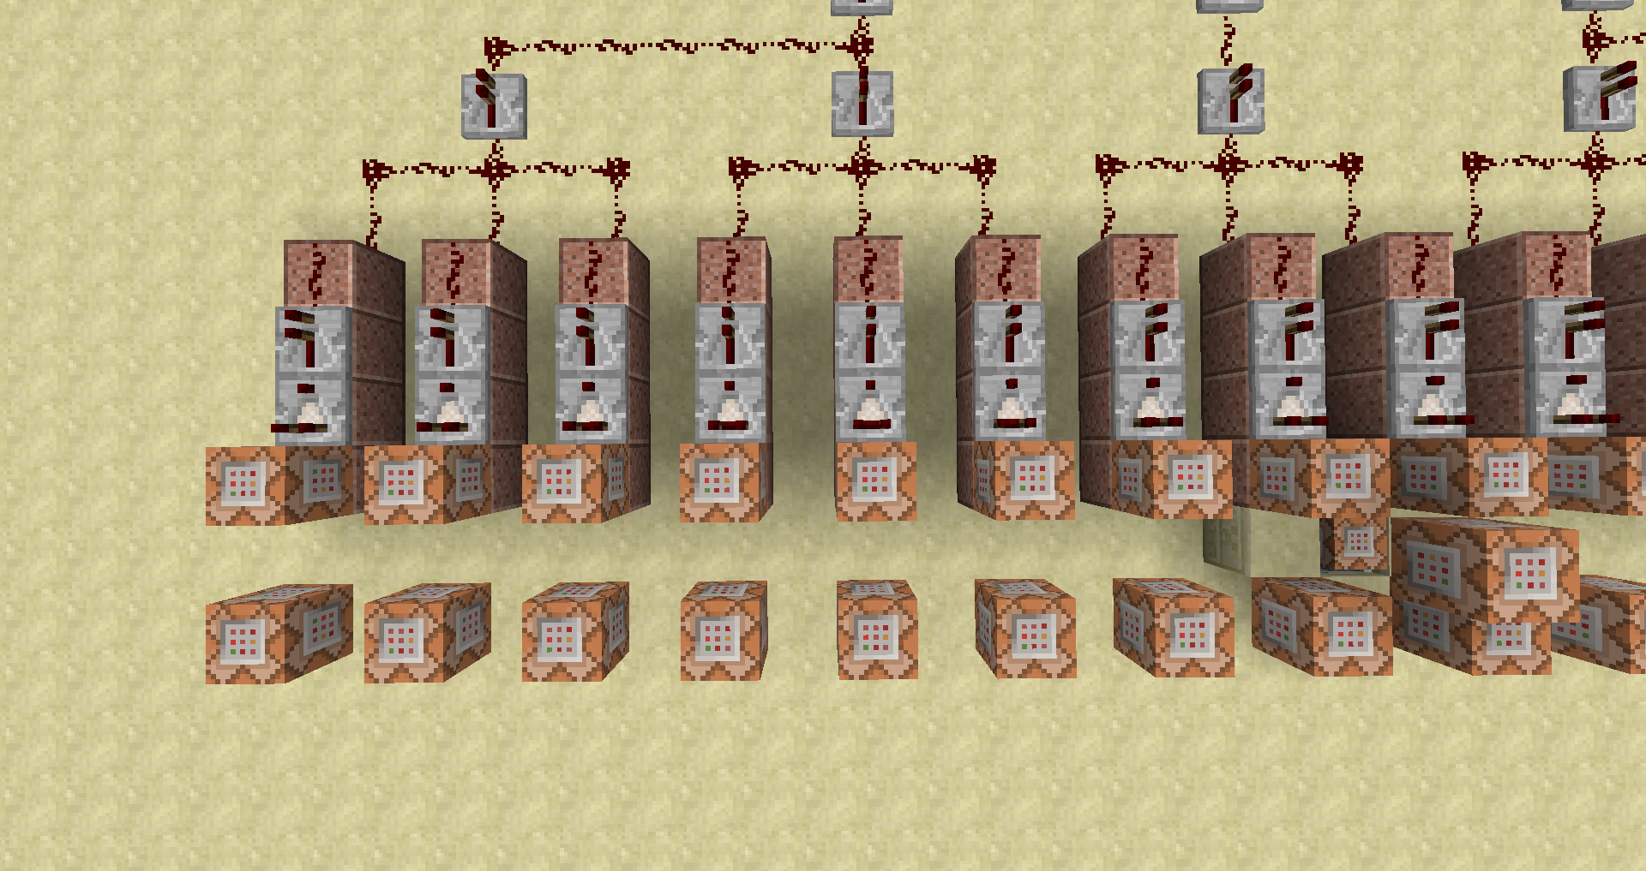

**7**

**6**

**5**

**4**

**6**

**5**

**4**

**3**

C4:

* **Test** de volgende **doelen**:

**score_Correct** gelijk aan 4

**score_Endcap** gelijk aan 4

**score_Mode** hoger dan of gelijk aan 1

**score_Fail** kleiner dan of gelijk aan 0

C5:

* **Test** de volgende **doelen**:

**score_Correct** gelijk aan 5

**score_Endcap** gelijk aan 5

**score_Mode** hoger dan of gelijk aan 1

**score_Fail** kleiner dan of gelijk aan 0

C6:

* **Test** de volgende **doelen**:

**score_Correct** gelijk aan 6

**score_Endcap** gelijk aan 6

**score_Mode** hoger dan of gelijk aan 1

**score_Fail** kleiner dan of gelijk aan 0

## 3de groep: commandoblokken 7-11

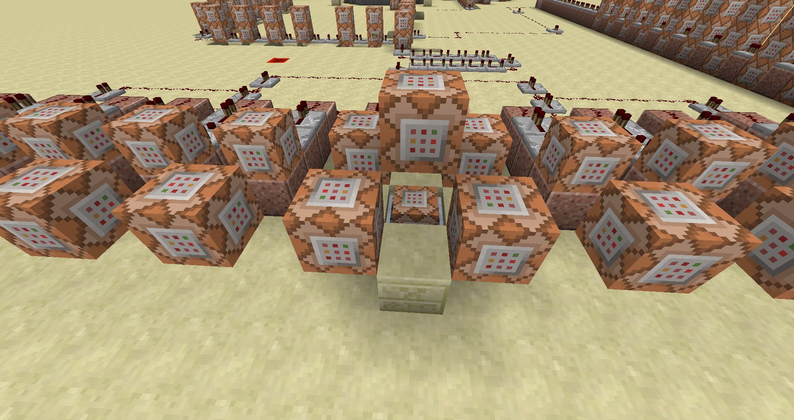 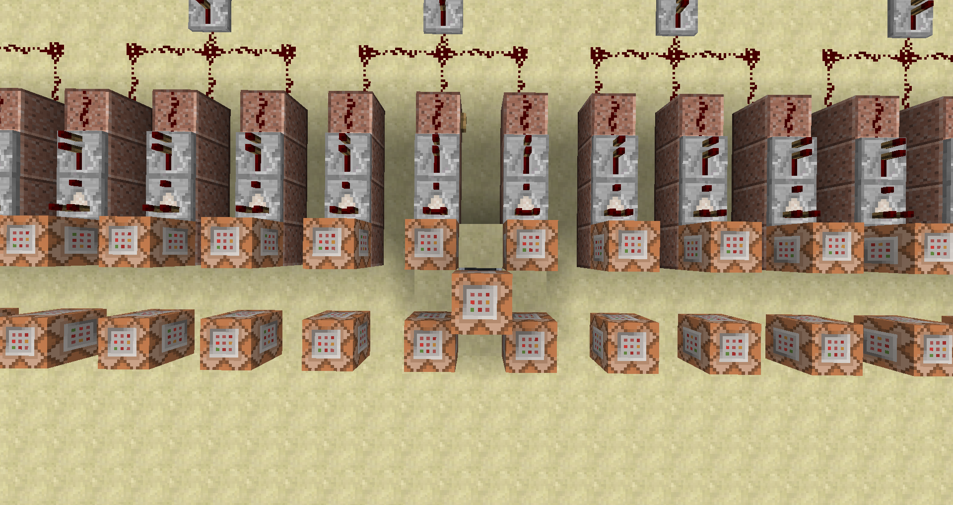

**CC1**

**10**

**9**

**87**

**7**

**10**

**9**

**8**

**7**

**6**

C7:

* **Test** de volgende **doelen**:

**score_Correct** gelijk aan 7

**score_Endcap** gelijk aan 7

**score_Mode** hoger dan of gelijk aan 1

**score_Fail** kleiner dan of gelijk aan 0

C8:

* **Test** de volgende **doelen**:

**score_Correct** gelijk aan 8

**score_Endcap** gelijk aan 8

**score_Mode** hoger dan of gelijk aan 1

**score_Fail** kleiner dan of gelijk aan 0

CC1:

* **Vul** een gebied met **redstone blokken** relatief van deze blok

|  |  |  |  |
| --- | --- | --- | --- |
| X1 | ~15 | X2 | ~-15 |
| Y1 | ~1 | Y2 | ~1 |
| Z1 | ~ | Z2 | ~ |

C9:

* **Vul** een gebied met **Lucht** relatief van deze blok

|  |  |  |  |
| --- | --- | --- | --- |
| X1 | ~15 | X2 | ~-15 |
| Y1 | ~-1 | Y2 | ~-1 |
| Z1 | ~ | Z2 | ~ |

C10:

* **Test** de volgende **doelen**:

**score_Correct** gelijk aan 9

**score_Endcap** gelijk aan 9

**score_Mode** hoger dan of gelijk aan 1

**score_Fail** kleiner dan of gelijk aan 0

## 4de groep: commandoblokken 11-13

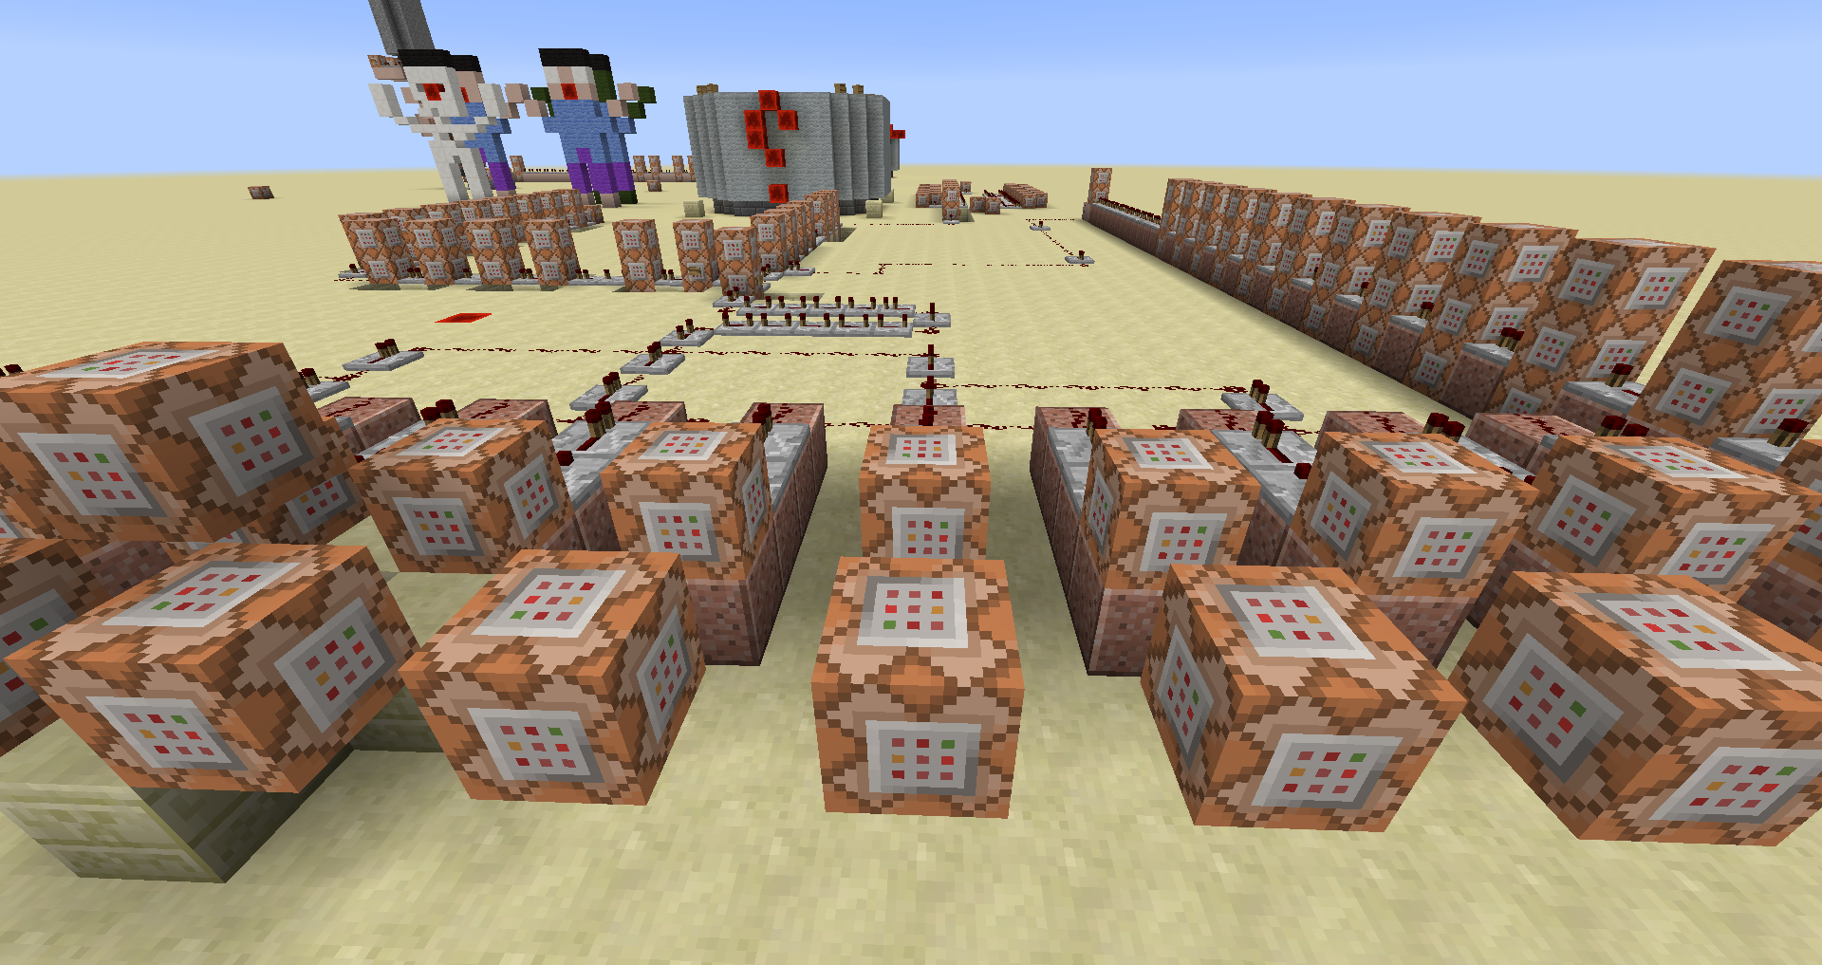 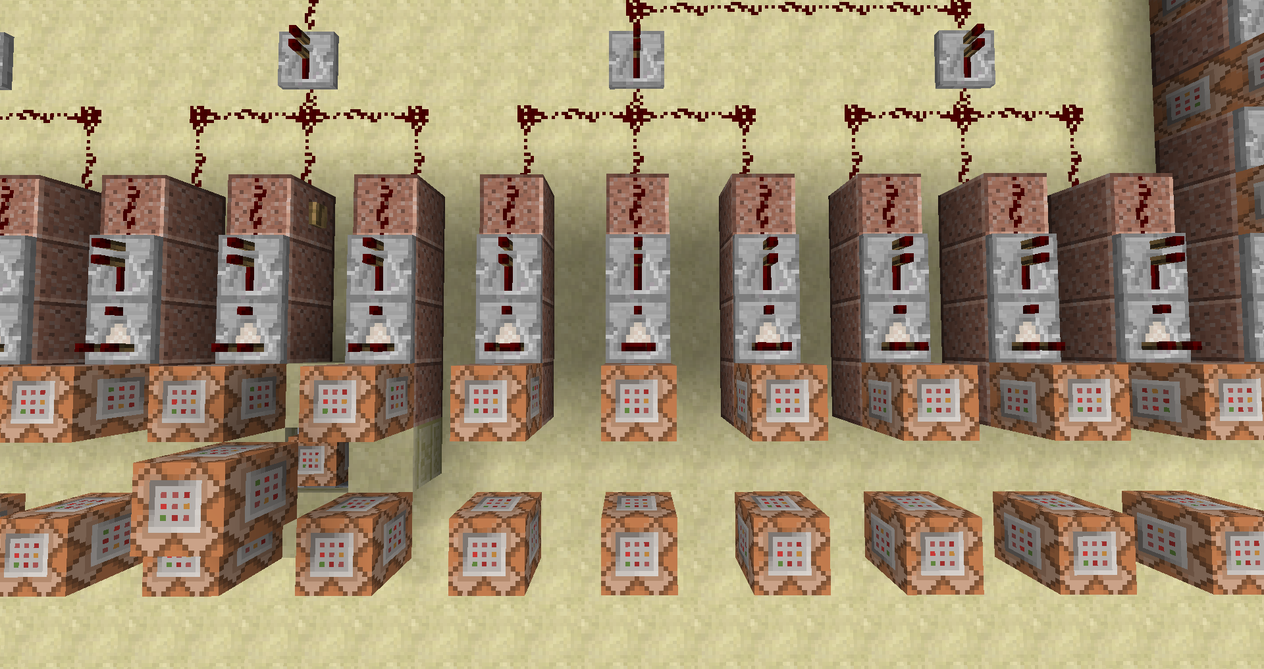

**13**

**12**

**11**

**14**

**13**

**12**

**11**

**10**

C11:

* **Test** de volgende **doelen**:

**score_Correct** gelijk aan 10

**score_Endcap** gelijk aan 10

**score_Mode** hoger dan of gelijk aan 1

**score_Fail** kleiner dan of gelijk aan 0

C12:

* **Test** de volgende **doelen**:

**score_Correct** gelijk aan 11

**score_Endcap** gelijk aan 11

**score_Mode** hoger dan of gelijk aan 1

**score_Fail** kleiner dan of gelijk aan 0

C13:

* **Test** de volgende **doelen**:

**score_Correct** gelijk aan 12

**score_Endcap** gelijk aan 12

**score_Mode** hoger dan of gelijk aan 1

**score_Fail** kleiner dan of gelijk aan 0

## 5de groep; commandoblokken 14-16

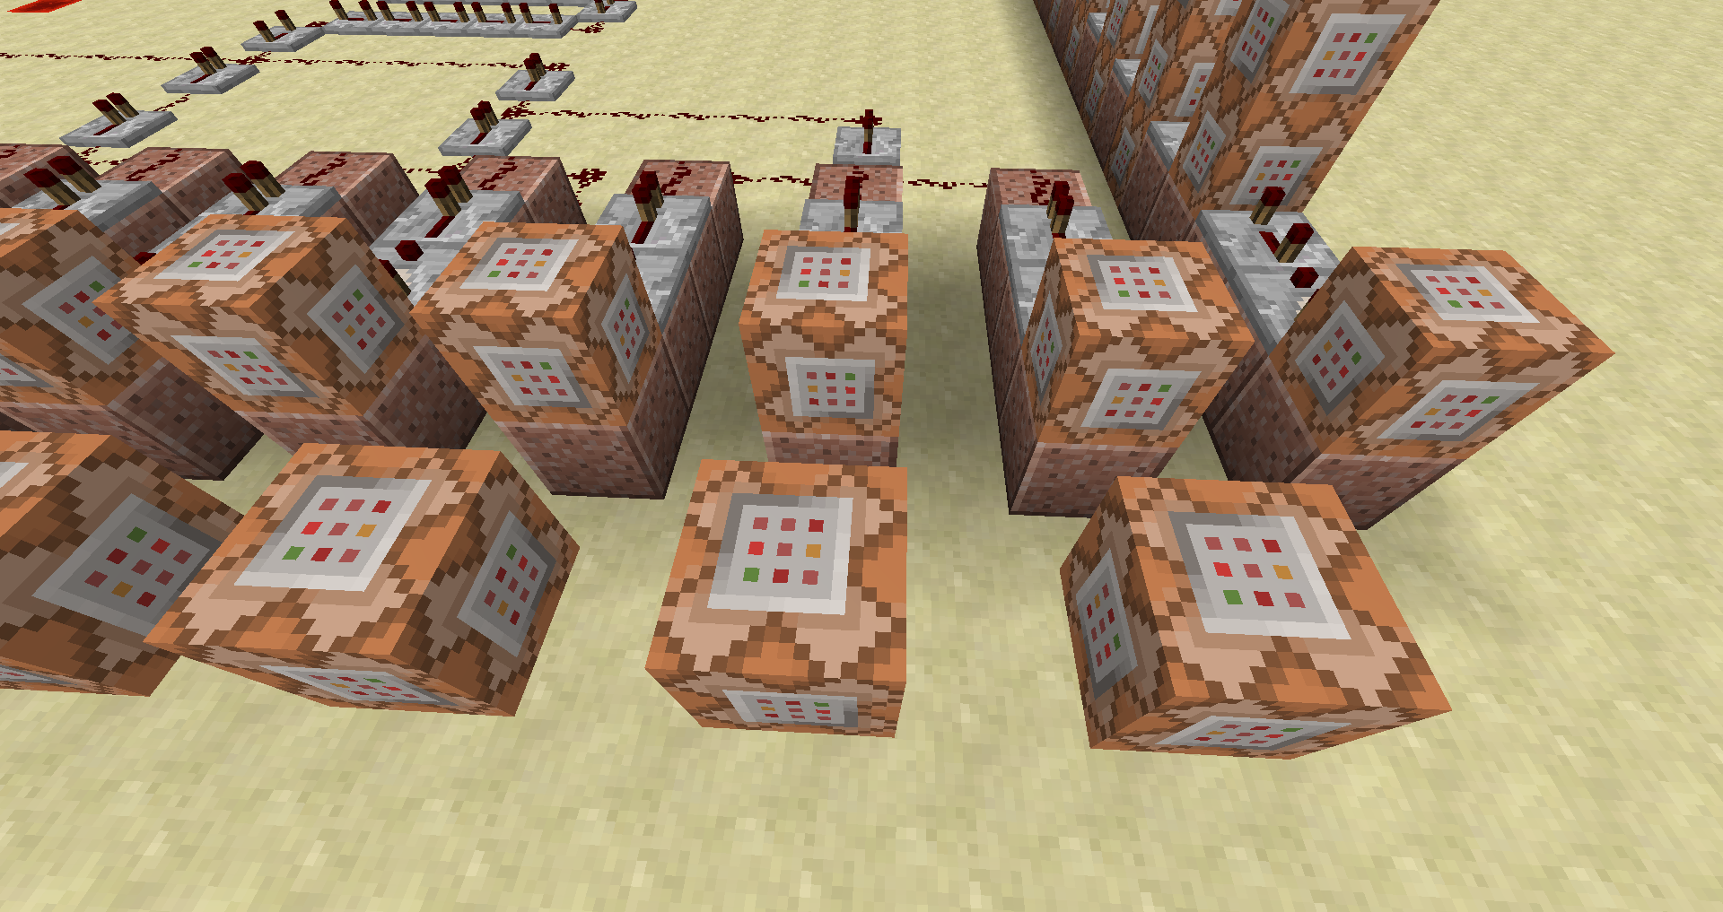 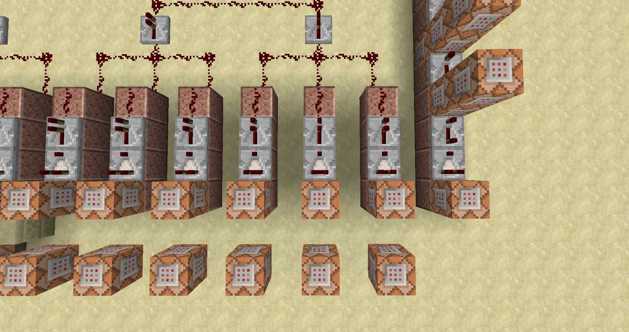

**16**

**15**

**14**

**16**

**15**

**14**

**13**

C14:

* **Test** de volgende **doelen**:

**score_Correct** gelijk aan 13

**score_Endcap** gelijk aan 13

**score_Mode** hoger dan of gelijk aan 1

**score_Fail** kleiner dan of gelijk aan 0

C15:

* **Test** de volgende **doelen**:

**score_Correct** gelijk aan 14

**score_Endcap** gelijk aan 14

**score_Mode** hoger dan of gelijk aan 1

**score_Fail** kleiner dan of gelijk aan 0

C16:

* **Test** de volgende **doelen**:

**score_Correct** gelijk aan 15

**score_Endcap** gelijk aan 15

**score_Mode** hoger dan of gelijk aan 1

**score_Fail** kleiner dan of gelijk aan 0

6de groep

# Appendix A: Tell Raw/Tittle/Subtittle/Sign/Book het json formaat

Bij elke van deze items kunnen we gestileerde tekst gebruiken. We doen dit aan de hand een json string.

Er bestaan een paar tools om u hierbij te helpen =><https://www.minecraftjson.com/>

We gaan de opbouw van het json formaat doen aan de hand van tellraw. (U kan hiermee experimenteren in de tutorial map)

Gewoon tekst weergeven met het json formaat

{“text”:”Wat tekst”}

/tellraw @a [{“text”:”Wat tekst”}]

We kunnen dit ook opsplitsen als het volgt en toch nog altijd dezelfde output zien.

{“text”:”Wat”},{“text”:”tekst”}

/tellraw @a [{“text”:”Wat”},{“text”:”tekst”}]

Als we gebruik willen maken van de selectors

{“text”:”Wat”},{“text”:”tekst”},{“text”:”voor”},{“selector”:”@p”}

/tellraw @a [{“text”:”Wat”},{“text”:”tekst”},{“text”:”voor”},{“selector”:”@p”}]

Elk van deze tekst objecten kunnen we voorzien van extra informatie

Zo kunnen we van elk woord het kleur veranderen, of onderlijnen, doorstrepen, een link van maken enzovoor

## Kleur

{“text”:”Wat”,”color”:”<kleur>”}

|  |  |  |  |  |  |  |  |
| --- | --- | --- | --- | --- | --- | --- | --- |
| Black |  | Dark_red |  | Dark_gray |  | Red |  |
| Dark_blue |  | Dark_purple |  | Blue |  | Light_purple |  |
| Dark_green |  | Gold |  | Green |  | Yellow |  |
| Dark_aqua |  | Gray |  | Aqua |  | White |  |

## Vette tekst

{“text”:”Wat”,”bold”:true}

## Schuine tekst

{“text”:”Wat”,”italic”:true}

## Onderstrepen van tekst

{“text”:”Wat”,”underlined”:true}

## Doorstrepen van tekst

{“text”:”Wat”,”strikethrough”:true}

## Obfuscatie

{“text”:”Wat”,”obfuscated”:true}



# Appendix B Block ID’s

|  |  |  |  |  |
| --- | --- | --- | --- | --- |
| **Icon** | **Dec** | **Hex** | **Name** | **Block** |
|  | 0 | 0 | minecraft:air | [Air](http://minecraft.gamepedia.com/Air) |
| [Stone.png](http://minecraft.gamepedia.com/File:Stone.png?version=ce443d030d48ac4d005319a6d1fa0b26) | 1 | 1 | minecraft:stone | [Stone](http://minecraft.gamepedia.com/Stone) [S](http://minecraft.gamepedia.com/Data_values#Stone)[B](http://minecraft.gamepedia.com/Data_values#Stone) |
| [Grass.png](http://minecraft.gamepedia.com/File:Grass.png?version=2da7ad9a533cf9618b8b05f3da105883) | 2 | 2 | minecraft:grass | [Grass Block](http://minecraft.gamepedia.com/Grass_Block) |
| [Dirt.png](http://minecraft.gamepedia.com/File:Dirt.png?version=e2eb9ee18e3b17138728163e70c01026) | 3 | 3 | minecraft:dirt | [Dirt](http://minecraft.gamepedia.com/Dirt) [S](http://minecraft.gamepedia.com/Data_values#Dirt)[B](http://minecraft.gamepedia.com/Data_values#Dirt) |
| [Cobblestone.png](http://minecraft.gamepedia.com/File:Cobblestone.png?version=c6c72b002cfc5a6a1419ba3edc674efa) | 4 | 4 | minecraft:cobblestone | [Cobblestone](http://minecraft.gamepedia.com/Cobblestone) |
| [Oak Wood Planks.png](http://minecraft.gamepedia.com/File:Oak_Wood_Planks.png) | 5 | 5 | minecraft:planks | [Wood Planks](http://minecraft.gamepedia.com/Wood_Planks) [S](http://minecraft.gamepedia.com/Data_values#Wood_Planks)[B](http://minecraft.gamepedia.com/Data_values#Wood_Planks) |
| [Sapling.png](http://minecraft.gamepedia.com/File:Sapling.png?version=4e8c164dd06d319b7e8f2a837360ea48) | 6 | 6 | minecraft:sapling | [Sapling](http://minecraft.gamepedia.com/Sapling) [S](http://minecraft.gamepedia.com/Data_values#Sapling)[B](http://minecraft.gamepedia.com/Data_values#Sapling) |
| [Bedrock.png](http://minecraft.gamepedia.com/File:Bedrock.png?version=4bae3c0bdf3aa9c7aff637dfd23d79c6) | 7 | 7 | minecraft:bedrock | [Bedrock](http://minecraft.gamepedia.com/Bedrock) |
| [Water.png](http://minecraft.gamepedia.com/File:Water.png?version=70b235a56d466de7b5ebe95950b7d459) | 8 | 8 | minecraft:flowing_water | [Water](http://minecraft.gamepedia.com/Water) [S](http://minecraft.gamepedia.com/Data_values#Water_and_Lava) |
| [Water.png](http://minecraft.gamepedia.com/File:Water.png?version=70b235a56d466de7b5ebe95950b7d459) | 9 | 9 | minecraft:water | Stationary [Water](http://minecraft.gamepedia.com/Water) [S](http://minecraft.gamepedia.com/Data_values#Water_and_Lava) |
| [Lava.png](http://minecraft.gamepedia.com/File:Lava.png?version=7bc6fbbbb4ec589581da6ee1b9f6c919) | 10 | A | minecraft:flowing_lava | [Lava](http://minecraft.gamepedia.com/Lava) [S](http://minecraft.gamepedia.com/Data_values#Water_and_Lava) |
| [Lava.png](http://minecraft.gamepedia.com/File:Lava.png?version=7bc6fbbbb4ec589581da6ee1b9f6c919) | 11 | B | minecraft:lava | Stationary [Lava](http://minecraft.gamepedia.com/Lava) [S](http://minecraft.gamepedia.com/Data_values#Water_and_Lava) |
| [Sand.png](http://minecraft.gamepedia.com/File:Sand.png?version=7a789946f631561e6f7e6d4cdbbad119) | 12 | C | minecraft:sand | [Sand](http://minecraft.gamepedia.com/Sand) [S](http://minecraft.gamepedia.com/Data_values#Sand)[B](http://minecraft.gamepedia.com/Data_values#Sand) |
| [Gravel.png](http://minecraft.gamepedia.com/File:Gravel.png?version=bad45746dc13d583e17a1d99af51f6f0) | 13 | D | minecraft:gravel | [Gravel](http://minecraft.gamepedia.com/Gravel) |
| [Gold Ore.png](http://minecraft.gamepedia.com/File:Gold_Ore.png) | 14 | E | minecraft:gold_ore | [Gold Ore](http://minecraft.gamepedia.com/Gold_Ore) |
| [Iron Ore.png](http://minecraft.gamepedia.com/File:Iron_Ore.png) | 15 | F | minecraft:iron_ore | [Iron Ore](http://minecraft.gamepedia.com/Iron_Ore) |

|  |  |  |  |  |
| --- | --- | --- | --- | --- |
| **Icon** | **Dec** | **Hex** | **Name** | **Block** |
| [Coal Ore.png](http://minecraft.gamepedia.com/File:Coal_Ore.png) | 16 | 10 | minecraft:coal_ore | [Coal Ore](http://minecraft.gamepedia.com/Coal_Ore) |
| [Wood.png](http://minecraft.gamepedia.com/File:Wood.png?version=739a29bef78db40441ac780e7cce80be) | 17 | 11 | minecraft:log | [Wood](http://minecraft.gamepedia.com/Wood) [S](http://minecraft.gamepedia.com/Data_values#Wood)[B](http://minecraft.gamepedia.com/Data_values#Wood) |
| [Leaves.png](http://minecraft.gamepedia.com/File:Leaves.png?version=41353569aee2208f5d5fe7cd11f1f5b5) | 18 | 12 | minecraft:leaves | [Leaves](http://minecraft.gamepedia.com/Leaves) [S](http://minecraft.gamepedia.com/Data_values#Leaves)[B](http://minecraft.gamepedia.com/Data_values#Leaves) |
| [Sponge.png](http://minecraft.gamepedia.com/File:Sponge.png?version=7f0dec9fe59978de1c446eb1d25009fc) | 19 | 13 | minecraft:sponge | [Sponge](http://minecraft.gamepedia.com/Sponge) [S](http://minecraft.gamepedia.com/Data_values#Sponge)[B](http://minecraft.gamepedia.com/Data_values#Sponge) |
| [Glass.png](http://minecraft.gamepedia.com/File:Glass.png?version=ce909cadc8168daf1ac0f6ee6d4137fd) | 20 | 14 | minecraft:glass | [Glass](http://minecraft.gamepedia.com/Glass) |
| [Lapis Lazuli Ore.png](http://minecraft.gamepedia.com/File:Lapis_Lazuli_Ore.png) | 21 | 15 | minecraft:lapis_ore | [Lapis Lazuli Ore](http://minecraft.gamepedia.com/Lapis_Lazuli_Ore) |
| [Lapis Lazuli Block.png](http://minecraft.gamepedia.com/File:Lapis_Lazuli_Block.png) | 22 | 16 | minecraft:lapis_block | [Lapis Lazuli Block](http://minecraft.gamepedia.com/Lapis_Lazuli_Block) |
| [Dispenser.png](http://minecraft.gamepedia.com/File:Dispenser.png?version=d0a0515f53396dd9dd6d083ab2ca7f5c) | 23 | 17 | minecraft:dispenser | [Dispenser](http://minecraft.gamepedia.com/Dispenser) [S](http://minecraft.gamepedia.com/Data_values#Dispenser_and_Dropper)[E](http://minecraft.gamepedia.com/Block_entity) |
| [Sandstone.png](http://minecraft.gamepedia.com/File:Sandstone.png?version=88e0167ffc14c16cbf136b6f5901b3f1) | 24 | 18 | minecraft:sandstone | [Sandstone](http://minecraft.gamepedia.com/Sandstone) [S](http://minecraft.gamepedia.com/Data_values#Sandstone)[B](http://minecraft.gamepedia.com/Data_values#Sandstone) |
| [Note Block.png](http://minecraft.gamepedia.com/File:Note_Block.png) | 25 | 19 | minecraft:noteblock | [Note Block](http://minecraft.gamepedia.com/Note_Block) [E](http://minecraft.gamepedia.com/Block_entity) |
| [Bed.png](http://minecraft.gamepedia.com/File:Bed.png?version=aeb4592001e81973ba96d56d4f144289) | 26 | 1A | minecraft:bed | [Bed](http://minecraft.gamepedia.com/Bed) [I](http://minecraft.gamepedia.com/Data_values#Item_IDs)[S](http://minecraft.gamepedia.com/Data_values#Bed) |
| [Powered Rail Off.png](http://minecraft.gamepedia.com/File:Powered_Rail_Off.png) | 27 | 1B | minecraft:golden_rail | [Powered Rail](http://minecraft.gamepedia.com/Powered_Rail) [S](http://minecraft.gamepedia.com/Data_values#Rails) |
| [Detector Rail.png](http://minecraft.gamepedia.com/File:Detector_Rail.png) | 28 | 1C | minecraft:detector_rail | [Detector Rail](http://minecraft.gamepedia.com/Detector_Rail) [S](http://minecraft.gamepedia.com/Data_values#Rails) |
| [Sticky Piston.png](http://minecraft.gamepedia.com/File:Sticky_Piston.png) | 29 | 1D | minecraft:sticky_piston | [Sticky Piston](http://minecraft.gamepedia.com/Piston) [S](http://minecraft.gamepedia.com/Data_values#Piston) |
| [WebBlock.png](http://minecraft.gamepedia.com/File:WebBlock.png?version=df2cb00d78f6588fa87516c69d4f8fe1) | 30 | 1E | minecraft:web | [Cobweb](http://minecraft.gamepedia.com/Cobweb) |
| [Tall Grass.png](http://minecraft.gamepedia.com/File:Tall_Grass.png) | 31 | 1F | minecraft:tallgrass | [Grass](http://minecraft.gamepedia.com/Grass) [S](http://minecraft.gamepedia.com/Data_values#Grass)[B](http://minecraft.gamepedia.com/Data_values#Grass) |

|  |  |  |  |  |
| --- | --- | --- | --- | --- |
| **Icon** | **Dec** | **Hex** | **Name** | **Block** |
| [Dead Bush.png](http://minecraft.gamepedia.com/File:Dead_Bush.png) | 32 | 20 | minecraft:deadbush | [Dead Bush](http://minecraft.gamepedia.com/Dead_Bush) |
| [Piston.png](http://minecraft.gamepedia.com/File:Piston.png?version=3945d55b941e1ce407eaa9d2873fdfb8) | 33 | 21 | minecraft:piston | [Piston](http://minecraft.gamepedia.com/Piston) [S](http://minecraft.gamepedia.com/Data_values#Piston) |
| [Block 34.png](http://minecraft.gamepedia.com/File:Block_34.png) | 34 | 22 | minecraft:piston_head | [Piston Head](http://minecraft.gamepedia.com/Piston#Piston_head) [S](http://minecraft.gamepedia.com/Data_values#Piston_Head) |
| [White Wool.png](http://minecraft.gamepedia.com/File:White_Wool.png) | 35 | 23 | minecraft:wool | [Wool](http://minecraft.gamepedia.com/Wool) [S](http://minecraft.gamepedia.com/Data_values#Wool.2C_Stained_Clay.2C_Stained_Glass_and_Carpet)[B](http://minecraft.gamepedia.com/Data_values#Wool.2C_Stained_Clay.2C_Stained_Glass_and_Carpet) |
|  | 36 | 24 | minecraft:piston_extension | [Block moved by Piston](http://minecraft.gamepedia.com/Piston#Piston_extension) [E](http://minecraft.gamepedia.com/Block_entity) |
| [Dandelion.png](http://minecraft.gamepedia.com/File:Dandelion.png?version=a0d571b8ee553ff405b6674b2b5886e6) | 37 | 25 | minecraft:yellow_flower | [Dandelion](http://minecraft.gamepedia.com/Flowers) |
| [Poppy.png](http://minecraft.gamepedia.com/File:Poppy.png?version=5c20de358459c6fa910b575b9712c000) | 38 | 26 | minecraft:red_flower | [Poppy](http://minecraft.gamepedia.com/Flowers) [S](http://minecraft.gamepedia.com/Data_values#Poppy)[B](http://minecraft.gamepedia.com/Data_values#Poppy) |
| [Brown Mushroom.png](http://minecraft.gamepedia.com/File:Brown_Mushroom.png) | 39 | 27 | minecraft:brown_mushroom | [Brown Mushroom](http://minecraft.gamepedia.com/Mushroom) |
| [Red Mushroom.png](http://minecraft.gamepedia.com/File:Red_Mushroom.png) | 40 | 28 | minecraft:red_mushroom | [Red Mushroom](http://minecraft.gamepedia.com/Mushroom) |
| [Block of Gold.png](http://minecraft.gamepedia.com/File:Block_of_Gold.png) | 41 | 29 | minecraft:gold_block | [Block of Gold](http://minecraft.gamepedia.com/Block_of_Gold) |
| [Block of Iron.png](http://minecraft.gamepedia.com/File:Block_of_Iron.png) | 42 | 2A | minecraft:iron_block | [Block of Iron](http://minecraft.gamepedia.com/Block_of_Iron) |
| [Double Stone Slab.png](http://minecraft.gamepedia.com/File:Double_Stone_Slab.png) | 43 | 2B | minecraft:double_stone_slab | [Double Stone Slab](http://minecraft.gamepedia.com/Slab) [S](http://minecraft.gamepedia.com/Data_values#Slabs)[B](http://minecraft.gamepedia.com/Data_values#Slabs) |
| [Stone Slab.png](http://minecraft.gamepedia.com/File:Stone_Slab.png) | 44 | 2C | minecraft:stone_slab | [Stone Slab](http://minecraft.gamepedia.com/Slab) [S](http://minecraft.gamepedia.com/Data_values#Slabs)[B](http://minecraft.gamepedia.com/Data_values#Slabs) |
| [Bricks.png](http://minecraft.gamepedia.com/File:Bricks.png?version=d55723069ef7cdf17a429e917ce6a3dd) | 45 | 2D | minecraft:brick_block | [Bricks](http://minecraft.gamepedia.com/Bricks) |
| [TNT.png](http://minecraft.gamepedia.com/File:TNT.png?version=e41b1b491722196c093e1dbc3c0d4cd9) | 46 | 2E | minecraft:tnt | [TNT](http://minecraft.gamepedia.com/TNT) |
| [Bookshelf.png](http://minecraft.gamepedia.com/File:Bookshelf.png?version=828dedc8c8cb3ee17cc49b072c2c5608) | 47 | 2F | minecraft:bookshelf | [Bookshelf](http://minecraft.gamepedia.com/Bookshelf) |

|  |  |  |  |  |
| --- | --- | --- | --- | --- |
| **Icon** | **Dec** | **Hex** | **Name** | **Block** |
| [Moss Stone.png](http://minecraft.gamepedia.com/File:Moss_Stone.png) | 48 | 30 | minecraft:mossy_cobblestone | [Moss Stone](http://minecraft.gamepedia.com/Moss_Stone) |
| [Obsidian.png](http://minecraft.gamepedia.com/File:Obsidian.png?version=78dbd27b8f422c50044696f180a32e0c) | 49 | 31 | minecraft:obsidian | [Obsidian](http://minecraft.gamepedia.com/Obsidian) |
| [Torch.png](http://minecraft.gamepedia.com/File:Torch.png?version=e88d21fd6067eff618ded9f9eb031996) | 50 | 32 | minecraft:torch | [Torch](http://minecraft.gamepedia.com/Torch) [S](http://minecraft.gamepedia.com/Data_values#Torches_and_Redstone_Torches) |
| [Fire.png](http://minecraft.gamepedia.com/File:Fire.png?version=ef1ce2bc9f9f4c589415a7f6dc78263f) | 51 | 33 | minecraft:fire | [Fire](http://minecraft.gamepedia.com/Fire) [S](http://minecraft.gamepedia.com/Data_values#Fire) |
| [Monster Spawner.png](http://minecraft.gamepedia.com/File:Monster_Spawner.png) | 52 | 34 | minecraft:mob_spawner | [Monster Spawner](http://minecraft.gamepedia.com/Monster_Spawner) [E](http://minecraft.gamepedia.com/Block_entity) |
| [Oak Wood Stairs.png](http://minecraft.gamepedia.com/File:Oak_Wood_Stairs.png) | 53 | 35 | minecraft:oak_stairs | [Oak Wood Stairs](http://minecraft.gamepedia.com/Stairs) [S](http://minecraft.gamepedia.com/Data_values#Stairs) |
| [Chest.png](http://minecraft.gamepedia.com/File:Chest.png?version=330078b94bfa7fb9ba52911172f6df58) | 54 | 36 | minecraft:chest | [Chest](http://minecraft.gamepedia.com/Chest) [S](http://minecraft.gamepedia.com/Data_values#Ladders.2C_Wall_Signs.2C_Furnaces.2C_Chests.2C_and_Wall_Banners)[E](http://minecraft.gamepedia.com/Block_entity) |
| [Redstone (Wire,Inventory).png](http://minecraft.gamepedia.com/File:Redstone_(Wire,Inventory).png) | 55 | 37 | minecraft:redstone_wire | [Redstone Wire](http://minecraft.gamepedia.com/Redstone) [I](http://minecraft.gamepedia.com/Data_values#Item_IDs)[S](http://minecraft.gamepedia.com/Data_values#Redstone_Wire) |
| [Diamond Ore.png](http://minecraft.gamepedia.com/File:Diamond_Ore.png) | 56 | 38 | minecraft:diamond_ore | [Diamond Ore](http://minecraft.gamepedia.com/Diamond_Ore) |
| [Block of Diamond.png](http://minecraft.gamepedia.com/File:Block_of_Diamond.png) | 57 | 39 | minecraft:diamond_block | [Block of Diamond](http://minecraft.gamepedia.com/Block_of_Diamond) |
| [Crafting Table.png](http://minecraft.gamepedia.com/File:Crafting_Table.png) | 58 | 3A | minecraft:crafting_table | [Crafting Table](http://minecraft.gamepedia.com/Crafting_Table) |
| [Crops.png](http://minecraft.gamepedia.com/File:Crops.png?version=be4df1c09081dc572cdf7586f4e7a22b) | 59 | 3B | minecraft:wheat | [Wheat](http://minecraft.gamepedia.com/Seeds) [I](http://minecraft.gamepedia.com/Data_values#Item_IDs)[S](http://minecraft.gamepedia.com/Data_values#Crops) |
| [Farmland.png](http://minecraft.gamepedia.com/File:Farmland.png?version=6236a39ae53e27e9d82261dfd9437ef1) | 60 | 3C | minecraft:farmland | [Farmland](http://minecraft.gamepedia.com/Farmland) [S](http://minecraft.gamepedia.com/Data_values#Farmland) |
| [Furnace.png](http://minecraft.gamepedia.com/File:Furnace.png?version=61adb9d83b71b232d0150f16050ed52a) | 61 | 3D | minecraft:furnace | [Furnace](http://minecraft.gamepedia.com/Furnace) [S](http://minecraft.gamepedia.com/Data_values#Ladders.2C_Wall_Signs.2C_Furnaces.2C_Chests.2C_and_Wall_Banners)[E](http://minecraft.gamepedia.com/Block_entity) |
| [Furnace (Active).png](http://minecraft.gamepedia.com/File:Furnace_(Active).png) | 62 | 3E | minecraft:lit_furnace | [Burning Furnace](http://minecraft.gamepedia.com/Furnace) [S](http://minecraft.gamepedia.com/Data_values#Ladders.2C_Wall_Signs.2C_Furnaces.2C_Chests.2C_and_Wall_Banners)[E](http://minecraft.gamepedia.com/Block_entity) |
| [Sign.png](http://minecraft.gamepedia.com/File:Sign.png?version=c195293b6e37b7366a6dfca18ed028cd) | 63 | 3F | minecraft:standing_sign | Standing [Sign](http://minecraft.gamepedia.com/Sign) [I](http://minecraft.gamepedia.com/Data_values#Item_IDs)[S](http://minecraft.gamepedia.com/Data_values#Sign_Posts_and_Standing_Banners)[E](http://minecraft.gamepedia.com/Block_entity) |

|  |  |  |  |  |
| --- | --- | --- | --- | --- |
| **Icon** | **Dec** | **Hex** | **Name** | **Block** |
| [Wooden Door.png](http://minecraft.gamepedia.com/File:Wooden_Door.png) | 64 | 40 | minecraft:wooden_door | [Oak Door](http://minecraft.gamepedia.com/Door) [I](http://minecraft.gamepedia.com/Data_values#Item_IDs)[S](http://minecraft.gamepedia.com/Data_values#Door) |
| [Ladder.png](http://minecraft.gamepedia.com/File:Ladder.png?version=e2df7d9b0fb89cadf927135e754c9228) | 65 | 41 | minecraft:ladder | [Ladder](http://minecraft.gamepedia.com/Ladder) [S](http://minecraft.gamepedia.com/Data_values#Ladders.2C_Wall_Signs.2C_Furnaces.2C_and_Chests) |
| [Rail.png](http://minecraft.gamepedia.com/File:Rail.png?version=1e91e8cecbc70d53eabd067540848e5c) | 66 | 42 | minecraft:rail | [Rail](http://minecraft.gamepedia.com/Rail) [S](http://minecraft.gamepedia.com/Data_values#Rails) |
| [Cobblestone Stairs.png](http://minecraft.gamepedia.com/File:Cobblestone_Stairs.png) | 67 | 43 | minecraft:stone_stairs | [Cobblestone Stairs](http://minecraft.gamepedia.com/Stairs) [S](http://minecraft.gamepedia.com/Data_values#Stairs) |
| [Wall Sign.png](http://minecraft.gamepedia.com/File:Wall_Sign.png) | 68 | 44 | minecraft:wall_sign | Wall [Sign](http://minecraft.gamepedia.com/Sign) [I](http://minecraft.gamepedia.com/Data_values#Item_IDs)[S](http://minecraft.gamepedia.com/Data_values#Ladders.2C_Wall_Signs.2C_Furnaces.2C_Chests.2C_and_Wall_Banners)[E](http://minecraft.gamepedia.com/Block_entity) |
| [Lever.png](http://minecraft.gamepedia.com/File:Lever.png?version=6a7691faf76129346750c96f1b0d9a97) | 69 | 45 | minecraft:lever | [Lever](http://minecraft.gamepedia.com/Lever) [S](http://minecraft.gamepedia.com/Data_values#Levers) |
| [Stone Pressure Plate.png](http://minecraft.gamepedia.com/File:Stone_Pressure_Plate.png) | 70 | 46 | minecraft:stone_pressure_plate | [Stone Pressure Plate](http://minecraft.gamepedia.com/Pressure_Plate) [S](http://minecraft.gamepedia.com/Data_values#Pressure_Plates) |
| [Iron Door.png](http://minecraft.gamepedia.com/File:Iron_Door.png) | 71 | 47 | minecraft:iron_door | [Iron Door](http://minecraft.gamepedia.com/Iron_Door) [I](http://minecraft.gamepedia.com/Data_values#Item_IDs)[S](http://minecraft.gamepedia.com/Data_values#Door) |
| [Wooden Pressure Plate.png](http://minecraft.gamepedia.com/File:Wooden_Pressure_Plate.png) | 72 | 48 | minecraft:wooden_pressure_plate | [Wooden Pressure Plate](http://minecraft.gamepedia.com/Pressure_Plate) [S](http://minecraft.gamepedia.com/Data_values#Pressure_Plates) |
| [Redstone Ore.png](http://minecraft.gamepedia.com/File:Redstone_Ore.png) | 73 | 49 | minecraft:redstone_ore | [Redstone Ore](http://minecraft.gamepedia.com/Redstone_Ore) |
| [Redstone Ore.png](http://minecraft.gamepedia.com/File:Redstone_Ore.png) | 74 | 4A | minecraft:lit_redstone_ore | Glowing [Redstone Ore](http://minecraft.gamepedia.com/Redstone_Ore" \o "Redstone Ore) |
| [Redstone (Torch, Inactive).png](http://minecraft.gamepedia.com/File:Redstone_(Torch,_Inactive).png) | 75 | 4B | minecraft:unlit_redstone_torch | [Redstone Torch](http://minecraft.gamepedia.com/Redstone_Torch) (inactive) [S](http://minecraft.gamepedia.com/Data_values#Torches_and_Redstone_Torches) |
| [Redstone (Torch, Active).png](http://minecraft.gamepedia.com/File:Redstone_(Torch,_Active).png) | 76 | 4C | minecraft:redstone_torch | [Redstone Torch](http://minecraft.gamepedia.com/Redstone_Torch) (active) [S](http://minecraft.gamepedia.com/Data_values#Torches_and_Redstone_Torches) |
| [Stone Button.png](http://minecraft.gamepedia.com/File:Stone_Button.png) | 77 | 4D | minecraft:stone_button | [Stone Button](http://minecraft.gamepedia.com/Button) [S](http://minecraft.gamepedia.com/Data_values#Buttons) |
| [Snow.png](http://minecraft.gamepedia.com/File:Snow.png?version=b872ac817175a847a3739057c6d4180f) | 78 | 4E | minecraft:snow_layer | [Snow](http://minecraft.gamepedia.com/Snow_(layer)) (layer) [S](http://minecraft.gamepedia.com/Data_values#Snow)[B](http://minecraft.gamepedia.com/Data_values#Snow) |
| [Ice.png](http://minecraft.gamepedia.com/File:Ice.png?version=00920f7954e1c9545f62ffda520e436b) | 79 | 4F | minecraft:ice | [Ice](http://minecraft.gamepedia.com/Ice) |

|  |  |  |  |  |
| --- | --- | --- | --- | --- |
| **Icon** | **Dec** | **Hex** | **Name** | **Block** |
| [Snow (Block).png](http://minecraft.gamepedia.com/File:Snow_(Block).png) | 80 | 50 | minecraft:snow | [Snow](http://minecraft.gamepedia.com/Snow) |
| [Cactus.png](http://minecraft.gamepedia.com/File:Cactus.png?version=f7602fe1a4dda4d7d431f66292a0fed5) | 81 | 51 | minecraft:cactus | [Cactus](http://minecraft.gamepedia.com/Cactus) [S](http://minecraft.gamepedia.com/Data_values#Cactus) |
| [Clay Block.png](http://minecraft.gamepedia.com/File:Clay_Block.png) | 82 | 52 | minecraft:clay | [Clay](http://minecraft.gamepedia.com/Clay_(block)) |
| [Sugar Canes.png](http://minecraft.gamepedia.com/File:Sugar_Canes.png) | 83 | 53 | minecraft:reeds | [Sugar Cane](http://minecraft.gamepedia.com/Sugar_Cane) [I](http://minecraft.gamepedia.com/Data_values#Item_IDs)[S](http://minecraft.gamepedia.com/Data_values#Sugar_Cane) |
| [Jukebox.png](http://minecraft.gamepedia.com/File:Jukebox.png?version=411ed828be1fdcae56701be43abf03ec) | 84 | 54 | minecraft:jukebox | [Jukebox](http://minecraft.gamepedia.com/Jukebox) [S](http://minecraft.gamepedia.com/Data_values#Jukebox)[E](http://minecraft.gamepedia.com/Block_entity) |
| [Fence.png](http://minecraft.gamepedia.com/File:Fence.png?version=534b7080b33abf5cfbdaf00c737cb062) | 85 | 55 | minecraft:fence | [Fence](http://minecraft.gamepedia.com/Fence) |
| [Pumpkin.png](http://minecraft.gamepedia.com/File:Pumpkin.png?version=134cf783c3b12ff31a6f7dff87a05c83) | 86 | 56 | minecraft:pumpkin | [Pumpkin](http://minecraft.gamepedia.com/Pumpkin) [S](http://minecraft.gamepedia.com/Data_values#Pumpkins_and_Jack-O-Lanterns) |
| [Netherrack.png](http://minecraft.gamepedia.com/File:Netherrack.png?version=cb3648758e47be3f0d049be9d8d476f9) | 87 | 57 | minecraft:netherrack | [Netherrack](http://minecraft.gamepedia.com/Netherrack) |
| [Soul Sand.png](http://minecraft.gamepedia.com/File:Soul_Sand.png) | 88 | 58 | minecraft:soul_sand | [Soul Sand](http://minecraft.gamepedia.com/Soul_Sand) |
| [Glowstone.png](http://minecraft.gamepedia.com/File:Glowstone.png?version=e2fdce22f7afa303e2231177f888d120) | 89 | 59 | minecraft:glowstone | [Glowstone](http://minecraft.gamepedia.com/Glowstone) |
| [Portal.png](http://minecraft.gamepedia.com/File:Portal.png?version=8c7b827dde7bdcba6efaa7b1e724d990) | 90 | 5A | minecraft:portal | Nether [Portal](http://minecraft.gamepedia.com/Nether_Portal_(block)) |
| [Jack o'Lantern.png](http://minecraft.gamepedia.com/File:Jack_o'Lantern.png) | 91 | 5B | minecraft:lit_pumpkin | [Jack o'Lantern](http://minecraft.gamepedia.com/Jack_o%27Lantern) [S](http://minecraft.gamepedia.com/Data_values#Pumpkins_and_Jack-O-Lanterns) |
| [Cake.png](http://minecraft.gamepedia.com/File:Cake.png?version=8ae049db84fdc1793a134c0ec3c590db) | 92 | 5C | minecraft:cake | [Cake](http://minecraft.gamepedia.com/Cake) [I](http://minecraft.gamepedia.com/Data_values#Item_IDs)[S](http://minecraft.gamepedia.com/Data_values#Cake) |
| [Redstone (Repeater, Inactive).png](http://minecraft.gamepedia.com/File:Redstone_(Repeater,_Inactive).png) | 93 | 5D | minecraft:unpowered_repeater | [Redstone Repeater](http://minecraft.gamepedia.com/Redstone_Repeater) (inactive) [I](http://minecraft.gamepedia.com/Data_values#Item_IDs)[S](http://minecraft.gamepedia.com/Data_values#Redstone_Repeater) |
| [Redstone (Repeater, Active).png](http://minecraft.gamepedia.com/File:Redstone_(Repeater,_Active).png) | 94 | 5E | minecraft:powered_repeater | [Redstone Repeater](http://minecraft.gamepedia.com/Redstone_Repeater) (active) [I](http://minecraft.gamepedia.com/Data_values#Item_IDs)[S](http://minecraft.gamepedia.com/Data_values#Redstone_Repeater) |
| [White Stained Glass.png](http://minecraft.gamepedia.com/File:White_Stained_Glass.png) | 95 | 5F | minecraft:stained_glass | [Stained Glass](http://minecraft.gamepedia.com/Stained_Glass) [S](http://minecraft.gamepedia.com/Data_values#Wool.2C_Stained_Clay.2C_Stained_Glass_and_Carpet)[B](http://minecraft.gamepedia.com/Data_values#Wool.2C_Stained_Clay.2C_Stained_Glass_and_Carpet) |

|  |  |  |  |  |
| --- | --- | --- | --- | --- |
| **Icon** | **Dec** | **Hex** | **Name** | **Block** |
| [Trapdoor.png](http://minecraft.gamepedia.com/File:Trapdoor.png?version=5f5768392deb7f475fc3b936176bff98) | 96 | 60 | minecraft:trapdoor | [Trapdoor](http://minecraft.gamepedia.com/Trapdoor) [S](http://minecraft.gamepedia.com/Data_values#Trapdoors) |
| [Stone.png](http://minecraft.gamepedia.com/File:Stone.png?version=ce443d030d48ac4d005319a6d1fa0b26) | 97 | 61 | minecraft:monster_egg | [Monster Egg](http://minecraft.gamepedia.com/Monster_Egg) [S](http://minecraft.gamepedia.com/Data_values#Monster_Egg)[B](http://minecraft.gamepedia.com/Data_values#Monster_Egg) |
| [Stone Brick.png](http://minecraft.gamepedia.com/File:Stone_Brick.png) | 98 | 62 | minecraft:stonebrick | [Stone Bricks](http://minecraft.gamepedia.com/Stone_Bricks) [S](http://minecraft.gamepedia.com/Data_values#Stone_Bricks)[B](http://minecraft.gamepedia.com/Data_values#Stone_Bricks) |
| [BrownMushroomCap.png](http://minecraft.gamepedia.com/File:BrownMushroomCap.png?version=bdc2bba3fc0b22723c43ddbf52596f65) | 99 | 63 | minecraft:brown_mushroom_block | [Brown Mushroom](http://minecraft.gamepedia.com/Mushroom_(block)) (block) [S](http://minecraft.gamepedia.com/Data_values#Brown_and_red_mushroom_blocks) |
| [RedMushroomCap.png](http://minecraft.gamepedia.com/File:RedMushroomCap.png?version=fcdef9501ac8dc0d7dde0aa1306e6be7) | 100 | 64 | minecraft:red_mushroom_block | [Red Mushroom](http://minecraft.gamepedia.com/Mushroom_(block)) (block) [S](http://minecraft.gamepedia.com/Data_values#Brown_and_red_mushroom_blocks) |
| [Iron Bars.png](http://minecraft.gamepedia.com/File:Iron_Bars.png) | 101 | 65 | minecraft:iron_bars | [Iron Bars](http://minecraft.gamepedia.com/Iron_Bars) |
| [Glass Pane.png](http://minecraft.gamepedia.com/File:Glass_Pane.png) | 102 | 66 | minecraft:glass_pane | [Glass Pane](http://minecraft.gamepedia.com/Glass_Pane) |
| [Melon (Block).png](http://minecraft.gamepedia.com/File:Melon_(Block).png) | 103 | 67 | minecraft:melon_block | [Melon](http://minecraft.gamepedia.com/Melon_(block)) |
| [Seed Stem.png](http://minecraft.gamepedia.com/File:Seed_Stem.png) | 104 | 68 | minecraft:pumpkin_stem | [Pumpkin Stem](http://minecraft.gamepedia.com/Pumpkin_Seeds) [S](http://minecraft.gamepedia.com/Data_values#Pumpkin_stem_and_Melon_stem) |
| [Seed Stem.png](http://minecraft.gamepedia.com/File:Seed_Stem.png) | 105 | 69 | minecraft:melon_stem | [Melon Stem](http://minecraft.gamepedia.com/Melon_Seeds) [S](http://minecraft.gamepedia.com/Data_values#Pumpkin_stem_and_Melon_stem) |
| [Vines.png](http://minecraft.gamepedia.com/File:Vines.png?version=961917b01ccdbc479070e126a289e5ac) | 106 | 6A | minecraft:vine | [Vines](http://minecraft.gamepedia.com/Vines) [S](http://minecraft.gamepedia.com/Data_values#Vines) |
| [Fence Gate (Closed).png](http://minecraft.gamepedia.com/File:Fence_Gate_(Closed).png) | 107 | 6B | minecraft:fence_gate | [Fence Gate](http://minecraft.gamepedia.com/Fence_Gate) [S](http://minecraft.gamepedia.com/Data_values#Fence_Gates) |
| [Brick Stairs.png](http://minecraft.gamepedia.com/File:Brick_Stairs.png) | 108 | 6C | minecraft:brick_stairs | [Brick Stairs](http://minecraft.gamepedia.com/Stairs) [S](http://minecraft.gamepedia.com/Data_values#Stairs) |
| [Stone Brick Stairs.png](http://minecraft.gamepedia.com/File:Stone_Brick_Stairs.png) | 109 | 6D | minecraft:stone_brick_stairs | [Stone Brick Stairs](http://minecraft.gamepedia.com/Stairs) [S](http://minecraft.gamepedia.com/Data_values#Stairs) |
| [Mycelium.png](http://minecraft.gamepedia.com/File:Mycelium.png?version=15548552fdee13725010e0c45df53bbc) | 110 | 6E | minecraft:mycelium | [Mycelium](http://minecraft.gamepedia.com/Mycelium) |
| [Lily Pad.png](http://minecraft.gamepedia.com/File:Lily_Pad.png) | 111 | 6F | minecraft:waterlily | [Lily Pad](http://minecraft.gamepedia.com/Lily_Pad) |

|  |  |  |  |  |
| --- | --- | --- | --- | --- |
| **Icon** | **Dec** | **Hex** | **Name** | **Block** |
| [Nether Brick.png](http://minecraft.gamepedia.com/File:Nether_Brick.png) | 112 | 70 | minecraft:nether_brick | [Nether Brick](http://minecraft.gamepedia.com/Nether_Brick) |
| [Nether Brick Fence.png](http://minecraft.gamepedia.com/File:Nether_Brick_Fence.png) | 113 | 71 | minecraft:nether_brick_fence | [Nether Brick Fence](http://minecraft.gamepedia.com/Nether_Brick_Fence) |
| [Nether Brick Stairs.png](http://minecraft.gamepedia.com/File:Nether_Brick_Stairs.png) | 114 | 72 | minecraft:nether_brick_stairs | [Nether Brick Stairs](http://minecraft.gamepedia.com/Stairs) [S](http://minecraft.gamepedia.com/Data_values#Stairs) |
| [Nether Wart.png](http://minecraft.gamepedia.com/File:Nether_Wart.png) | 115 | 73 | minecraft:nether_wart | [Nether Wart](http://minecraft.gamepedia.com/Nether_Wart) [I](http://minecraft.gamepedia.com/Data_values#Item_IDs)[S](http://minecraft.gamepedia.com/Data_values#Nether_Wart) |
| [Enchantment Table.png](http://minecraft.gamepedia.com/File:Enchantment_Table.png) | 116 | 74 | minecraft:enchanting_table | [Enchantment Table](http://minecraft.gamepedia.com/Enchantment_Table) [E](http://minecraft.gamepedia.com/Block_entity) |
| [Brewing Stand.png](http://minecraft.gamepedia.com/File:Brewing_Stand.png) | 117 | 75 | minecraft:brewing_stand | [Brewing Stand](http://minecraft.gamepedia.com/Brewing_Stand) [I](http://minecraft.gamepedia.com/Data_values#Item_IDs)[S](http://minecraft.gamepedia.com/Data_values#Brewing_Stand)[E](http://minecraft.gamepedia.com/Block_entity) |
| [Cauldron.png](http://minecraft.gamepedia.com/File:Cauldron.png?version=7be34edca1a623934d60bfc4805c1256) | 118 | 76 | minecraft:cauldron | [Cauldron](http://minecraft.gamepedia.com/Cauldron) [I](http://minecraft.gamepedia.com/Data_values#Item_IDs)[S](http://minecraft.gamepedia.com/Data_values#Cauldron) |
| [End Portal.png](http://minecraft.gamepedia.com/File:End_Portal.png) | 119 | 77 | minecraft:end_portal | [End Portal](http://minecraft.gamepedia.com/End_Portal_(block)) [E](http://minecraft.gamepedia.com/Block_entity) |
| [End Portal Frame.png](http://minecraft.gamepedia.com/File:End_Portal_Frame.png) | 120 | 78 | minecraft:end_portal_frame | [End Portal Frame](http://minecraft.gamepedia.com/End_Portal_Frame) [S](http://minecraft.gamepedia.com/Data_values#End_Portal_Frame) |
| [End Stone.png](http://minecraft.gamepedia.com/File:End_Stone.png) | 121 | 79 | minecraft:end_stone | [End Stone](http://minecraft.gamepedia.com/End_Stone) |
| [Dragon Egg.png](http://minecraft.gamepedia.com/File:Dragon_Egg.png) | 122 | 7A | minecraft:dragon_egg | [Dragon Egg](http://minecraft.gamepedia.com/Dragon_Egg) |
| [Redstone Lamp.png](http://minecraft.gamepedia.com/File:Redstone_Lamp.png) | 123 | 7B | minecraft:redstone_lamp | [Redstone Lamp](http://minecraft.gamepedia.com/Redstone_Lamp) (inactive) |
| [Redstone Lamp (Active).png](http://minecraft.gamepedia.com/File:Redstone_Lamp_(Active).png) | 124 | 7C | minecraft:lit_redstone_lamp | [Redstone Lamp](http://minecraft.gamepedia.com/Redstone_Lamp) (active) |
| [Oak Wood Planks.png](http://minecraft.gamepedia.com/File:Oak_Wood_Planks.png) | 125 | 7D | minecraft:double_wooden_slab | [Double Wooden Slab](http://minecraft.gamepedia.com/Slabs) [S](http://minecraft.gamepedia.com/Data_values#Slabs)[B](http://minecraft.gamepedia.com/Data_values#Slabs) |
| [Oak-Wood Slab.png](http://minecraft.gamepedia.com/File:Oak-Wood_Slab.png) | 126 | 7E | minecraft:wooden_slab | [Wooden Slab](http://minecraft.gamepedia.com/Slabs) [S](http://minecraft.gamepedia.com/Data_values#Slabs)[B](http://minecraft.gamepedia.com/Data_values#Slabs) |
| [Cocoa Plant.png](http://minecraft.gamepedia.com/File:Cocoa_Plant.png) | 127 | 7F | minecraft:cocoa | [Cocoa](http://minecraft.gamepedia.com/Cocoa) [I](http://minecraft.gamepedia.com/Data_values#Item_IDs)[S](http://minecraft.gamepedia.com/Data_values#Cocoas) |

|  |  |  |  |  |
| --- | --- | --- | --- | --- |
| **Icon** | **Dec** | **Hex** | **Name** | **Block** |
| [Sandstone Stairs.png](http://minecraft.gamepedia.com/File:Sandstone_Stairs.png) | 128 | 80 | minecraft:sandstone_stairs | [Sandstone Stairs](http://minecraft.gamepedia.com/Stairs) [S](http://minecraft.gamepedia.com/Data_values#Stairs) |
| [Emerald Ore.png](http://minecraft.gamepedia.com/File:Emerald_Ore.png) | 129 | 81 | minecraft:emerald_ore | [Emerald Ore](http://minecraft.gamepedia.com/Emerald_Ore) |
| [Ender Chest.png](http://minecraft.gamepedia.com/File:Ender_Chest.png) | 130 | 82 | minecraft:ender_chest | [Ender Chest](http://minecraft.gamepedia.com/Ender_Chest) [S](http://minecraft.gamepedia.com/Data_values#Ladders.2C_Wall_Signs.2C_Furnaces.2C_Chests.2C_and_Wall_Banners)[E](http://minecraft.gamepedia.com/Block_entity) |
| [Tripwire Hook.png](http://minecraft.gamepedia.com/File:Tripwire_Hook.png) | 131 | 83 | minecraft:tripwire_hook | [Tripwire Hook](http://minecraft.gamepedia.com/Tripwire_Hook) [S](http://minecraft.gamepedia.com/Data_values#Tripwire_Hook) |
| [Tripwire.png](http://minecraft.gamepedia.com/File:Tripwire.png?version=251d969e6f6410cf281c94e20ad6a208) | 132 | 84 | minecraft:tripwire | [Tripwire](http://minecraft.gamepedia.com/String#Tripwire) [I](http://minecraft.gamepedia.com/Data_values#Item_IDs)[S](http://minecraft.gamepedia.com/Data_values#Tripwire) |
| [Block of Emerald.png](http://minecraft.gamepedia.com/File:Block_of_Emerald.png) | 133 | 85 | minecraft:emerald_block | [Block of Emerald](http://minecraft.gamepedia.com/Block_of_Emerald) |
| [Spruce Wood Stairs.png](http://minecraft.gamepedia.com/File:Spruce_Wood_Stairs.png) | 134 | 86 | minecraft:spruce_stairs | [Spruce Wood Stairs](http://minecraft.gamepedia.com/Stairs) [S](http://minecraft.gamepedia.com/Data_values#Stairs) |
| [Birch Wood Stairs.png](http://minecraft.gamepedia.com/File:Birch_Wood_Stairs.png) | 135 | 87 | minecraft:birch_stairs | [Birch Wood Stairs](http://minecraft.gamepedia.com/Stairs) [S](http://minecraft.gamepedia.com/Data_values#Stairs) |
| [Jungle Wood Stairs.png](http://minecraft.gamepedia.com/File:Jungle_Wood_Stairs.png) | 136 | 88 | minecraft:jungle_stairs | [Jungle Wood Stairs](http://minecraft.gamepedia.com/Stairs) [S](http://minecraft.gamepedia.com/Data_values#Stairs) |
| [Impulse Command Block.png](http://minecraft.gamepedia.com/File:Impulse_Command_Block.png) | 137 | 89 | minecraft:command_block | [Command Block](http://minecraft.gamepedia.com/Command_Block) [E](http://minecraft.gamepedia.com/Block_entity) |
| [Beacon Block.png](http://minecraft.gamepedia.com/File:Beacon_Block.png) | 138 | 8A | minecraft:beacon | [Beacon](http://minecraft.gamepedia.com/Beacon) [E](http://minecraft.gamepedia.com/Block_entity) |
| [Cobblestone Wall.png](http://minecraft.gamepedia.com/File:Cobblestone_Wall.png) | 139 | 8B | minecraft:cobblestone_wall | [Cobblestone Wall](http://minecraft.gamepedia.com/Cobblestone_Wall) [S](http://minecraft.gamepedia.com/Data_values#Cobblestone_Walls)[B](http://minecraft.gamepedia.com/Data_values#Cobblestone_Walls) |
| [Flower Pot.png](http://minecraft.gamepedia.com/File:Flower_Pot.png) | 140 | 8C | minecraft:flower_pot | [Flower Pot](http://minecraft.gamepedia.com/Flower_Pot) [I](http://minecraft.gamepedia.com/Data_values#Item_IDs)[S](http://minecraft.gamepedia.com/Data_values#Flower_Pots)[E](http://minecraft.gamepedia.com/Block_entity) |
| [Carrot (Block).png](http://minecraft.gamepedia.com/File:Carrot_(Block).png) | 141 | 8D | minecraft:carrots | [Carrot](http://minecraft.gamepedia.com/Carrot) [I](http://minecraft.gamepedia.com/Data_values#Item_IDs)[S](http://minecraft.gamepedia.com/Data_values#Crops) |
| [Potatoes (Block).png](http://minecraft.gamepedia.com/File:Potatoes_(Block).png) | 142 | 8E | minecraft:potatoes | [Potato](http://minecraft.gamepedia.com/Potato) [I](http://minecraft.gamepedia.com/Data_values#Item_IDs)[S](http://minecraft.gamepedia.com/Data_values#Crops) |
| [Wooden Button.png](http://minecraft.gamepedia.com/File:Wooden_Button.png) | 143 | 8F | minecraft:wooden_button | [Wooden Button](http://minecraft.gamepedia.com/Button) [S](http://minecraft.gamepedia.com/Data_values#Buttons) |

|  |  |  |  |  |
| --- | --- | --- | --- | --- |
| **Icon** | **Dec** | **Hex** | **Name** | **Block** |
| [Skeleton Skull.png](http://minecraft.gamepedia.com/File:Skeleton_Skull.png) | 144 | 90 | minecraft:skull | [Mob head](http://minecraft.gamepedia.com/Mob_head) [I](http://minecraft.gamepedia.com/Data_values#Item_IDs)[S](http://minecraft.gamepedia.com/Data_values#Heads)[E](http://minecraft.gamepedia.com/Block_entity) |
| [Anvil.png](http://minecraft.gamepedia.com/File:Anvil.png?version=e81c0bbed446b0c4a559849986bcbafe) | 145 | 91 | minecraft:anvil | [Anvil](http://minecraft.gamepedia.com/Anvil) [S](http://minecraft.gamepedia.com/Data_values#Anvil)[B](http://minecraft.gamepedia.com/Data_values#Anvil) |
| [Trapped Chest.png](http://minecraft.gamepedia.com/File:Trapped_Chest.png) | 146 | 92 | minecraft:trapped_chest | [Trapped Chest](http://minecraft.gamepedia.com/Trapped_Chest) [S](http://minecraft.gamepedia.com/Data_values#Ladders.2C_Wall_Signs.2C_Furnaces.2C_Chests.2C_and_Wall_Banners)[E](http://minecraft.gamepedia.com/Block_entity) |
| [Weighted Pressure Plate (Light).png](http://minecraft.gamepedia.com/File:Weighted_Pressure_Plate_(Light).png) | 147 | 93 | minecraft:light_weighted_pressure_plate | [Weighted Pressure Plate](http://minecraft.gamepedia.com/Weighted_Pressure_Plate)(Light) [S](http://minecraft.gamepedia.com/Data_values#Pressure_Plates) |
| [Weighted Pressure Plate (Heavy).png](http://minecraft.gamepedia.com/File:Weighted_Pressure_Plate_(Heavy).png) | 148 | 94 | minecraft:heavy_weighted_pressure_plate | [Weighted Pressure Plate](http://minecraft.gamepedia.com/Weighted_Pressure_Plate)(Heavy) [S](http://minecraft.gamepedia.com/Data_values#Pressure_Plates) |
| [Redstone Comparator (inactive).png](http://minecraft.gamepedia.com/File:Redstone_Comparator_(inactive).png) | 149 | 95 | minecraft:unpowered_comparator | [Redstone Comparator](http://minecraft.gamepedia.com/Redstone_Comparator) [I](http://minecraft.gamepedia.com/Data_values#Item_IDs)[S](http://minecraft.gamepedia.com/Data_values#Redstone_Comparator) |
| [Redstone Comparator (active).png](http://minecraft.gamepedia.com/File:Redstone_Comparator_(active).png) | 150 | 96 | minecraft:powered_comparator | [Redstone Comparator](http://minecraft.gamepedia.com/Redstone_Comparator)(deprecated) [S](http://minecraft.gamepedia.com/Data_values#Redstone_Comparator) |
| [Daylight Sensor.png](http://minecraft.gamepedia.com/File:Daylight_Sensor.png) | 151 | 97 | minecraft:daylight_detector | [Daylight Sensor](http://minecraft.gamepedia.com/Daylight_Sensor) [E](http://minecraft.gamepedia.com/Block_entity) |
| [Block of Redstone.png](http://minecraft.gamepedia.com/File:Block_of_Redstone.png) | 152 | 98 | minecraft:redstone_block | [Block of Redstone](http://minecraft.gamepedia.com/Block_of_Redstone) |
| [Nether Quartz Ore.png](http://minecraft.gamepedia.com/File:Nether_Quartz_Ore.png) | 153 | 99 | minecraft:quartz_ore | [Nether Quartz Ore](http://minecraft.gamepedia.com/Nether_Quartz_Ore) |
| [Hopper.png](http://minecraft.gamepedia.com/File:Hopper.png?version=5527fa32f5c20260e8a2ec1ced175a54) | 154 | 9A | minecraft:hopper | [Hopper](http://minecraft.gamepedia.com/Hopper) [S](http://minecraft.gamepedia.com/Data_values#Hoppers)[E](http://minecraft.gamepedia.com/Block_entity) |
| [Block of Quartz.png](http://minecraft.gamepedia.com/File:Block_of_Quartz.png) | 155 | 9B | minecraft:quartz_block | [Block of Quartz](http://minecraft.gamepedia.com/Block_of_Quartz) [S](http://minecraft.gamepedia.com/Data_values#Block_of_Quartz)[B](http://minecraft.gamepedia.com/Data_values#Block_of_Quartz) |
| [Quartz Stairs.png](http://minecraft.gamepedia.com/File:Quartz_Stairs.png) | 156 | 9C | minecraft:quartz_stairs | [Quartz Stairs](http://minecraft.gamepedia.com/Stairs) [S](http://minecraft.gamepedia.com/Data_values#Stairs) |
| [Activator Rail.png](http://minecraft.gamepedia.com/File:Activator_Rail.png) | 157 | 9D | minecraft:activator_rail | [Activator Rail](http://minecraft.gamepedia.com/Activator_Rail) [S](http://minecraft.gamepedia.com/Data_values#Rails) |
| [Dropper.png](http://minecraft.gamepedia.com/File:Dropper.png?version=254ec2370c9ca6e22a13fd8ae0668053) | 158 | 9E | minecraft:dropper | [Dropper](http://minecraft.gamepedia.com/Dropper) [S](http://minecraft.gamepedia.com/Data_values#Dispensers_and_Droppers)[E](http://minecraft.gamepedia.com/Block_entity) |
| [White Stained Clay.png](http://minecraft.gamepedia.com/File:White_Stained_Clay.png) | 159 | 9F | minecraft:stained_hardened_clay | [Stained Clay](http://minecraft.gamepedia.com/Stained_Clay) [S](http://minecraft.gamepedia.com/Data_values#Wool.2C_Stained_Clay.2C_Stained_Glass_and_Carpet)[B](http://minecraft.gamepedia.com/Data_values#Wool.2C_Stained_Clay.2C_Stained_Glass_and_Carpet) |

|  |  |  |  |  |
| --- | --- | --- | --- | --- |
| **Icon** | **Dec** | **Hex** | **Name** | **Block** |
| [White Stained Glass Pane.png](http://minecraft.gamepedia.com/File:White_Stained_Glass_Pane.png) | 160 | A0 | minecraft:stained_glass_pane | [Stained Glass Pane](http://minecraft.gamepedia.com/Stained_Glass_Pane) [S](http://minecraft.gamepedia.com/Data_values#Wool.2C_Stained_Clay.2C_Stained_Glass_and_Carpet)[B](http://minecraft.gamepedia.com/Data_values#Wool.2C_Stained_Clay.2C_Stained_Glass_and_Carpet) |
| [Leaves.png](http://minecraft.gamepedia.com/File:Leaves.png?version=41353569aee2208f5d5fe7cd11f1f5b5) | 161 | A1 | minecraft:leaves2 | [Leaves](http://minecraft.gamepedia.com/Leaves) (Acacia/Dark Oak) [S](http://minecraft.gamepedia.com/Data_values#Leaves)[B](http://minecraft.gamepedia.com/Data_values#Leaves) |
| [Acacia Wood.png](http://minecraft.gamepedia.com/File:Acacia_Wood.png) | 162 | A2 | minecraft:log2 | [Wood](http://minecraft.gamepedia.com/Wood) (Acacia/Dark Oak) [S](http://minecraft.gamepedia.com/Data_values#Wood)[B](http://minecraft.gamepedia.com/Data_values#Wood) |
| [Acacia Wood Stairs.png](http://minecraft.gamepedia.com/File:Acacia_Wood_Stairs.png) | 163 | A3 | minecraft:acacia_stairs | [Acacia Wood Stairs](http://minecraft.gamepedia.com/Stairs) [S](http://minecraft.gamepedia.com/Data_values#Stairs) |
| [Dark Oak Wood Stairs.png](http://minecraft.gamepedia.com/File:Dark_Oak_Wood_Stairs.png) | 164 | A4 | minecraft:dark_oak_stairs | [Dark Oak Wood Stairs](http://minecraft.gamepedia.com/Stairs) [S](http://minecraft.gamepedia.com/Data_values#Stairs) |
| [Slime Block.png](http://minecraft.gamepedia.com/File:Slime_Block.png) | 165 | A5 | minecraft:slime | [Slime Block](http://minecraft.gamepedia.com/Slime_Block) |
| [Barrier.png](http://minecraft.gamepedia.com/File:Barrier.png?version=3c2d5a19e316b3dd49c0c399fbefc20e) | 166 | A6 | minecraft:barrier | [Barrier](http://minecraft.gamepedia.com/Barrier) |
| [Iron Trapdoor.png](http://minecraft.gamepedia.com/File:Iron_Trapdoor.png) | 167 | A7 | minecraft:iron_trapdoor | [Iron Trapdoor](http://minecraft.gamepedia.com/Iron_Trapdoor) [S](http://minecraft.gamepedia.com/Data_values#Trapdoors) |
| [Prismarine.png](http://minecraft.gamepedia.com/File:Prismarine.png?version=07b5f2686b5aebf8eeaf1540f138a0d3) | 168 | A8 | minecraft:prismarine | [Prismarine](http://minecraft.gamepedia.com/Prismarine) [S](http://minecraft.gamepedia.com/Data_values#Prismarine)[B](http://minecraft.gamepedia.com/Data_values#Prismarine) |
| [Sea Lantern.png](http://minecraft.gamepedia.com/File:Sea_Lantern.png) | 169 | A9 | minecraft:sea_lantern | [Sea Lantern](http://minecraft.gamepedia.com/Sea_Lantern) |
| [Hay Bale.png](http://minecraft.gamepedia.com/File:Hay_Bale.png) | 170 | AA | minecraft:hay_block | [Hay Bale](http://minecraft.gamepedia.com/Hay_Bale) [S](http://minecraft.gamepedia.com/Data_values#Hay_Bale) |
| [White Carpet.png](http://minecraft.gamepedia.com/File:White_Carpet.png) | 171 | AB | minecraft:carpet | [Carpet](http://minecraft.gamepedia.com/Carpet) [S](http://minecraft.gamepedia.com/Data_values#Wool.2C_Stained_Clay.2C_Stained_Glass_and_Carpet)[B](http://minecraft.gamepedia.com/Data_values#Wool.2C_Stained_Clay.2C_Stained_Glass_and_Carpet) |
| [Hardened Clay.png](http://minecraft.gamepedia.com/File:Hardened_Clay.png) | 172 | AC | minecraft:hardened_clay | [Hardened Clay](http://minecraft.gamepedia.com/Hardened_Clay) |
| [Block of Coal.png](http://minecraft.gamepedia.com/File:Block_of_Coal.png) | 173 | AD | minecraft:coal_block | [Block of Coal](http://minecraft.gamepedia.com/Block_of_Coal) |
| [Packed Ice.png](http://minecraft.gamepedia.com/File:Packed_Ice.png) | 174 | AE | minecraft:packed_ice | [Packed Ice](http://minecraft.gamepedia.com/Packed_Ice) |
| [Sunflower.png](http://minecraft.gamepedia.com/File:Sunflower.png?version=8ff30ba5d461f78781e12ac6463210c6) | 175 | AF | minecraft:double_plant | [Large Flowers](http://minecraft.gamepedia.com/Flowers) [S](http://minecraft.gamepedia.com/Data_values#Large_Flowers)[B](http://minecraft.gamepedia.com/Data_values#Large_Flowers) |

|  |  |  |  |  |
| --- | --- | --- | --- | --- |
| **Icon** | **Dec** | **Hex** | **Name** | **Block** |
| [Free-standing Banner (Small).png](http://minecraft.gamepedia.com/File:Free-standing_Banner_(Small).png) | 176 | B0 | minecraft:standing_banner | Standing [Banner](http://minecraft.gamepedia.com/Banner) [I](http://minecraft.gamepedia.com/Data_values#Item_IDs)[S](http://minecraft.gamepedia.com/Data_values#Sign_Posts_and_Standing_Banners)[E](http://minecraft.gamepedia.com/Block_entity) |
| [Wall-mounted Banner (Small).png](http://minecraft.gamepedia.com/File:Wall-mounted_Banner_(Small).png) | 177 | B1 | minecraft:wall_banner | Wall [Banner](http://minecraft.gamepedia.com/Banner) [I](http://minecraft.gamepedia.com/Data_values#Item_IDs)[S](http://minecraft.gamepedia.com/Data_values#Ladders.2C_Wall_Signs.2C_Furnaces.2C_Chests.2C_and_Wall_Banners)[E](http://minecraft.gamepedia.com/Block_entity) |
| [Inverted Daylight Sensor.png](http://minecraft.gamepedia.com/File:Inverted_Daylight_Sensor.png) | 178 | B2 | minecraft:daylight_detector_inverted | [Inverted Daylight Sensor](http://minecraft.gamepedia.com/Daylight_Sensor) [E](http://minecraft.gamepedia.com/Block_entity) |
| [Red Sandstone.png](http://minecraft.gamepedia.com/File:Red_Sandstone.png) | 179 | B3 | minecraft:red_sandstone | [Red Sandstone](http://minecraft.gamepedia.com/Red_Sandstone) [S](http://minecraft.gamepedia.com/Data_values#Red_Sandstone)[B](http://minecraft.gamepedia.com/Data_values#Red_Sandstone) |
| [Red Sandstone Stairs.png](http://minecraft.gamepedia.com/File:Red_Sandstone_Stairs.png) | 180 | B4 | minecraft:red_sandstone_stairs | [Red Sandstone Stairs](http://minecraft.gamepedia.com/Stairs) [S](http://minecraft.gamepedia.com/Data_values#Stairs) |
| [Red Sandstone.png](http://minecraft.gamepedia.com/File:Red_Sandstone.png) | 181 | B5 | minecraft:double_stone_slab2 | [Double Red Sandstone Slab](http://minecraft.gamepedia.com/Slabs) [S](http://minecraft.gamepedia.com/Data_values#Slabs) |
| [Red Sandstone Slab.png](http://minecraft.gamepedia.com/File:Red_Sandstone_Slab.png) | 182 | B6 | minecraft:stone_slab2 | [Red Sandstone Slab](http://minecraft.gamepedia.com/Slabs) [S](http://minecraft.gamepedia.com/Data_values#Slabs) |
| [Spruce Fence Gate (Closed).png](http://minecraft.gamepedia.com/File:Spruce_Fence_Gate_(Closed).png) | 183 | B7 | minecraft:spruce_fence_gate | [Spruce Fence Gate](http://minecraft.gamepedia.com/Fence_Gate) |
| [Birch Fence Gate (Closed).png](http://minecraft.gamepedia.com/File:Birch_Fence_Gate_(Closed).png) | 184 | B8 | minecraft:birch_fence_gate | [Birch Fence Gate](http://minecraft.gamepedia.com/Fence_Gate) |
| [Jungle Fence Gate (Closed).png](http://minecraft.gamepedia.com/File:Jungle_Fence_Gate_(Closed).png) | 185 | B9 | minecraft:jungle_fence_gate | [Jungle Fence Gate](http://minecraft.gamepedia.com/Fence_Gate) |
| [Dark Oak Fence Gate (Closed).png](http://minecraft.gamepedia.com/File:Dark_Oak_Fence_Gate_(Closed).png) | 186 | BA | minecraft:dark_oak_fence_gate | [Dark Oak Fence Gate](http://minecraft.gamepedia.com/Fence_Gate) |
| [Acacia Fence Gate (Closed).png](http://minecraft.gamepedia.com/File:Acacia_Fence_Gate_(Closed).png) | 187 | BB | minecraft:acacia_fence_gate | [Acacia Fence Gate](http://minecraft.gamepedia.com/Fence_Gate) |
| [Spruce Fence.png](http://minecraft.gamepedia.com/File:Spruce_Fence.png) | 188 | BC | minecraft:spruce_fence | [Spruce Fence](http://minecraft.gamepedia.com/Fence) |
| [Birch Fence.png](http://minecraft.gamepedia.com/File:Birch_Fence.png) | 189 | BD | minecraft:birch_fence | [Birch Fence](http://minecraft.gamepedia.com/Fence) |
| [Jungle Fence.png](http://minecraft.gamepedia.com/File:Jungle_Fence.png) | 190 | BE | minecraft:jungle_fence | [Jungle Fence](http://minecraft.gamepedia.com/Fence) |
| [Dark Oak Fence.png](http://minecraft.gamepedia.com/File:Dark_Oak_Fence.png) | 191 | BF | minecraft:dark_oak_fence | [Dark Oak Fence](http://minecraft.gamepedia.com/Fence) |

|  |  |  |  |  |
| --- | --- | --- | --- | --- |
| **Icon** | **Dec** | **Hex** | **Name** | **Block** |
| [Acacia Fence.png](http://minecraft.gamepedia.com/File:Acacia_Fence.png) | 192 | C0 | minecraft:acacia_fence | [Acacia Fence](http://minecraft.gamepedia.com/Fence) |
| [Spruce Door.png](http://minecraft.gamepedia.com/File:Spruce_Door.png) | 193 | C1 | minecraft:spruce_door | [Spruce Door](http://minecraft.gamepedia.com/Door) [I](http://minecraft.gamepedia.com/Data_values#Item_IDs)[S](http://minecraft.gamepedia.com/Data_values#Door) |
| [Birch Door.png](http://minecraft.gamepedia.com/File:Birch_Door.png) | 194 | C2 | minecraft:birch_door | [Birch Door](http://minecraft.gamepedia.com/Door) [I](http://minecraft.gamepedia.com/Data_values#Item_IDs)[S](http://minecraft.gamepedia.com/Data_values#Door) |
| [Jungle Door.png](http://minecraft.gamepedia.com/File:Jungle_Door.png) | 195 | C3 | minecraft:jungle_door | [Jungle Door](http://minecraft.gamepedia.com/Door) [I](http://minecraft.gamepedia.com/Data_values#Item_IDs)[S](http://minecraft.gamepedia.com/Data_values#Door) |
| [Acacia Door.png](http://minecraft.gamepedia.com/File:Acacia_Door.png) | 196 | C4 | minecraft:acacia_door | [Acacia Door](http://minecraft.gamepedia.com/Door) [I](http://minecraft.gamepedia.com/Data_values#Item_IDs)[S](http://minecraft.gamepedia.com/Data_values#Door) |
| [Dark Oak Door.png](http://minecraft.gamepedia.com/File:Dark_Oak_Door.png) | 197 | C5 | minecraft:dark_oak_door | [Dark Oak Door](http://minecraft.gamepedia.com/Door) [I](http://minecraft.gamepedia.com/Data_values#Item_IDs)[S](http://minecraft.gamepedia.com/Data_values#Door) |
| [End Rod.png](http://minecraft.gamepedia.com/File:End_Rod.png) | 198 | C6 | minecraft:end_rod | [End Rod](http://minecraft.gamepedia.com/End_Rod) |
| [Chorus Plant.png](http://minecraft.gamepedia.com/File:Chorus_Plant.png) | 199 | C7 | minecraft:chorus_plant | [Chorus Plant](http://minecraft.gamepedia.com/Chorus_Plant) |
| [Chorus Flower.png](http://minecraft.gamepedia.com/File:Chorus_Flower.png) | 200 | C8 | minecraft:chorus_flower | [Chorus Flower](http://minecraft.gamepedia.com/Chorus_Flower) |
| [Purpur Block.png](http://minecraft.gamepedia.com/File:Purpur_Block.png) | 201 | C9 | minecraft:purpur_block | [Purpur Block](http://minecraft.gamepedia.com/Purpur_Block) |
| [Purpur Pillar.png](http://minecraft.gamepedia.com/File:Purpur_Pillar.png) | 202 | CA | minecraft:purpur_pillar | [Purpur Pillar](http://minecraft.gamepedia.com/Purpur_Block) |
| [Purpur Stairs.png](http://minecraft.gamepedia.com/File:Purpur_Stairs.png) | 203 | CB | minecraft:purpur_stairs | [Purpur Stairs](http://minecraft.gamepedia.com/Stairs) |
| [Purpur Block.png](http://minecraft.gamepedia.com/File:Purpur_Block.png) | 204 | CC | minecraft:purpur_double_slab | [Purpur Double Slab](http://minecraft.gamepedia.com/Slabs) |
| [Purpur Slab.png](http://minecraft.gamepedia.com/File:Purpur_Slab.png) | 205 | CD | minecraft:purpur_slab | [Purpur Slab](http://minecraft.gamepedia.com/Slabs) |
| [End Stone Bricks.png](http://minecraft.gamepedia.com/File:End_Stone_Bricks.png) | 206 | CE | minecraft:end_bricks | [End Stone Bricks](http://minecraft.gamepedia.com/End_Stone_Bricks) |
| [Beetroot (Block).png](http://minecraft.gamepedia.com/File:Beetroot_(Block).png) | 207 | CF | minecraft:beetroots | [Beetroot Seeds](http://minecraft.gamepedia.com/Beetroot_Seeds) |

|  |  |  |  |  |
| --- | --- | --- | --- | --- |
| **Icon** | **Dec** | **Hex** | **Name** | **Block** |
| [Grass Path.png](http://minecraft.gamepedia.com/File:Grass_Path.png) | 208 | D0 | minecraft:grass_path | [Grass Path](http://minecraft.gamepedia.com/Grass_Path) |
| [End Gateway (block).png](http://minecraft.gamepedia.com/File:End_Gateway_(block).png) | 209 | D1 | minecraft:end_gateway | [End Gateway](http://minecraft.gamepedia.com/End_Gateway_(block)) |
| [Repeating Command Block.png](http://minecraft.gamepedia.com/File:Repeating_Command_Block.png) | 210 | D2 | minecraft:repeating_command_block | [Repeating Command Block](http://minecraft.gamepedia.com/Repeating_Command_Block) [E](http://minecraft.gamepedia.com/Block_entity) |
| [Chain Command Block.png](http://minecraft.gamepedia.com/File:Chain_Command_Block.png) | 211 | D3 | minecraft:chain_command_block | [Chain Command Block](http://minecraft.gamepedia.com/Chain_Command_Block) [E](http://minecraft.gamepedia.com/Block_entity) |
| [Ice.png](http://minecraft.gamepedia.com/File:Ice.png?version=00920f7954e1c9545f62ffda520e436b) | 212 | D4 | minecraft:frosted_ice | [Frosted Ice](http://minecraft.gamepedia.com/Frosted_Ice) [S](http://minecraft.gamepedia.com/Data_values#Frosted_Ice) |
| [Structure Block Save.png](http://minecraft.gamepedia.com/File:Structure_Block_Save.png) | 255 | FF | minecraft:structure_block | [Structure Block](http://minecraft.gamepedia.com/Structure_Block) [S](http://minecraft.gamepedia.com/Data_values#Structure_Block)[E](http://minecraft.gamepedia.com/Block_entity) |